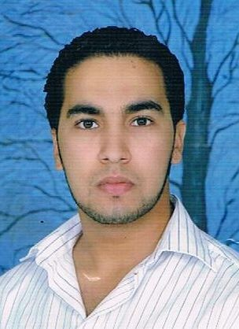
curicculum vitae
name:ali address:Emirates dubai nationality:morocco date of birth:04-02-1984
E- Mail:ali-394436@2freemail.com

EDUCATION

2011: Master Diploma in Islamic studies. 2008: Bachelors diploma in Islamic studies. 2005: Baccalaureate diploma in Arts.

WORK EXPERIENCE
2018/2019:Teaching with school in qatar.
2013-2016: Teaching in Morocco.
2010-2013: teaching with school private in morocoo.

INTERNSHIPS
2010: School days in the teaching methods of forensic science. 2012: School days curriculam and teaching methods instruction. 2013: A training course in curanriculum d teaching methods.
2018:training course in accounting.

SKILLs
language: Arabic Good.
English Moderate. French Moderate.

computers: Excel,Word,Acces .

favtorite hobbies

football, poetry,marketing of products electronically and field.

