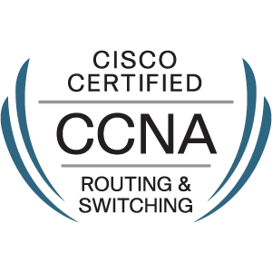
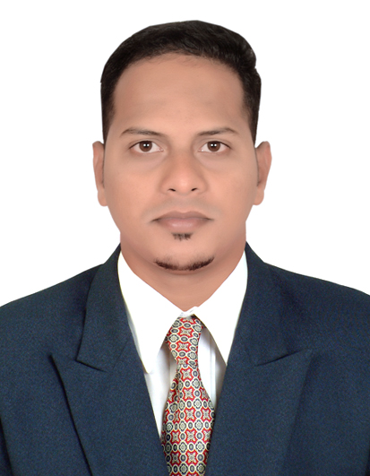
RESUME

SARWAR

Systems Consultant IT Professional with Technical Support

E-Mail: sarwar-394463@2freemail.com
Availability: Immediately Visa Status- Visit Visa Expire on – 29/11/2019

Profile Summary

- CCNA CERTIFIED
- MCSA CERTIFIED

Position Sought : Networking / Technical Support Engineer

Career Objective: A multitasking Network and Technical Engineer having around 3+ years of work experience in Technical and professional Remote support.

Experience
1
 | Duration | February 2018 to August 2019
 | Job Role | IT Support Engineer
 | Responsibilities | - Installing and configuring computer hardware, software, systems, networks, printers and scanners  - Monitoring and maintaining computer systems and networks  - Responding in a timely manner to service issues and requests  - Providing technical support across the company (this may be in person or over the phone)  - Setting up accounts for new users  - Repairing and replacing equipment as necessary  - Possibly training more junior staff members

2
 | Client | Jio
 | Duration | Oct 2016 to Oct 2017
 | Job Role | Technical Support Engineer (IT Support)
 | Responsibilities | - Working as Service Desk Engineer/Technical Engineer with various hardware and software support.  - 1st level of Software Support for various organizational software.  - Attending the Support calls and investigating the issues and its resolution through remote access.  - Working closely with Admin Team for various issues resolution within the specified SLA with standard organizational Reporting.  - Working as Symantec Antivirus Patch Engineer.  - Deploying Operating System updates by SCCM Client.

3
 | Client | ESIC and DHL
 | Duration | Oct 2015 to July 2016
 | Job Role | Desktop Support Engineer
 | Responsibilities | - Installation of Desktops, Laptops, application software’s etc.  - Create, change, and delete user accounts as per request.  - Installation of printers with sharing, scanners other Hardware &Troubleshooting of devices.  - Working on Active Directory Services, DNS Services and DHCP Services.  - Coordination with customers through mail and phones.  - Help Desk software, raising and closing tickets as per the  Service Level Agreement (SLA).  - Handling helpdesk queries, assigning engineers to solve  problems, collecting call status reports from Engineers.  - Client issue escalation by online/onsite or telephonic support.

Certification

Certification |  |  |  | Institute |  |  |  | Status
Microsoft Certified Solutions |  |  | CMS InfoTech, Mumbai |  |  |  |  | Completed
Associate (MCSA)
Cisco Certified Network |  |  | SEED InfoTech, Pune |  |  |  |  | Completed
Associate (CCNA)
 |  |  |  | Education
Examination |  |  | Board/University |  |  |  | Year of |  |  | Aggregate
 |  |  |  |  |  |  | Passing |  |  | Percentage
Bachelor of Science in |  |  | Mumbai University, |  |  |  | April-2015 |  |  | 60.25
Information Technology |  |  | India |  |  |  |  |  |  | (First Class)
Higher Secondary |  |  | Kolhapur Board, |  |  |  | February-2011 |  |  | 52.33
Certificate |  |  | India |  |  |  |  |  |  | (A Grade)
 |  |  |  | Personal Data
Name |  | SARWAR
Designation |  | Bachelor of Science in Information Technology.
Date of Birth |  | 03rd February 1994 |  |  | Nationality : Indian
Current Address |  | Room no-303,Muwaileh Commercial,Sharjah.
Passport Details

 |  | Date of Issue | 27/10/2014
Place of Issue | Mumbai | Date of Expiry | 26/10/2024
Declaration

.
I hereby declare the above information is given by me is true and fair to the best of my knowledge.

SARWAR

