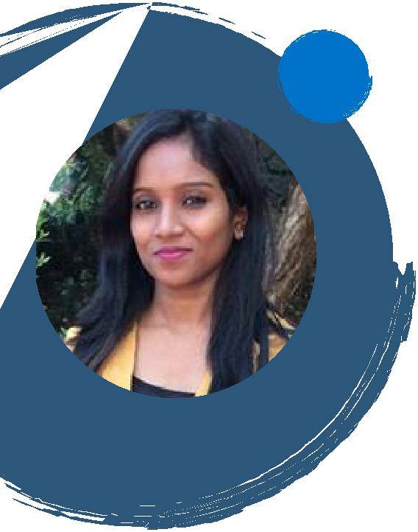

Neenu-394482@2freemail.com

Visa Status: Resident Visa

DR. NEENU

A postgraduate in Public Health Dentistry with a keen interest in health care management and administration with a multitude of versatile skills that transfer into any administrative setting to create and maintain high level of productivity and efficiency.

Education

Rajiv Gandhi University of Health Sciences, Bengaluru, India

- Master of Dental Surgery - Public Health Dentistry (2015 – 2018) Graduating as a batch topper and securing 7th rank in the overall university with an aggregate of 73%

Dr. MGR Medical University, Tamil Nadu, India

- Bachelor of Dental Surgery (2009 - 2014) Graduating with an aggregate of 64.7%

Experience

December 2018–July 2019
Assistant Professor• Calicut, Kerala, India

Job role:
- Lecture classes for final year and 3rd year BDS students

- Lecture classes for diploma students

- Carrying out administrative works in the department

- Clinical training for 3rd year and final year students

- Academic scheduling for students (scheduling lecture classes and exams)

- Visiting primary health center every week along with students and providing treatments to the patients

- Guiding students to carry out short term research projects

January 2015 – May 2015

Dental Surgeon • Kerala, India

Job role:

- Performing oral prophylaxis, extraction of teeth, restorative treatments and prescription of medicines

Skills

- Good English proficiency ( IELTS Academics score 7.0) o Expertise in general dental practice.

o Health care management and administration. o Strategic planning and management.

o Creative problem solving.
o Public speaking and creative writing.
o Familiarity with the ethical and medico-legal issues.

o Proficiency in handling computerized tools and the internet. o Time management

o Expert in primary care dentistry
o Trained in clinical, social and behavioral research.

o Thorough understanding of coordinating with students from different background. o Trained as tobacco intervention initiative specialist from the Governing Council. o Community outreach programs organized and accomplished - 54

o School dental health programs organized and accomplished – 42

Other Achievements

Scientific Publications

- S Neenu, Sharma V, Bhat PK, Alashetty P. Barriers in providing dental treatment to HIV/AIDS patients.IJCMR 2017 ; 4(6): 1402-1405

- Bhat PK, Alashetty P, S Neenu, S Sowmya. Role of Dentist in Mass Disaster. Int J Dent Health Sci 2017: 4(6): 1468-1474.

Research works
- Dental caries, BMI and socioeconomic status among preschoolers in anganwadi and private

preschools in Bangalore city, India.

- Knowledge and awareness teledentistry among interns and postgraduates in Bangalore city-A cross-sectional study.

Continuing Dental Education Programmes, Workshops & Conferences attended

- Continuing Dental Education programme on research and publications.

- Continuing Dental Education programme on “Exploring new thoughts in Public Health Dentistry”.
- Continuing dental education programme on current concepts of oral cancer.

- Attended national conference organized by Indian Association of Public Health Dentistry in 2015 and 2016.
- Workshop on primary care dentistry.

- Workshop on biostatistics and epidemiology for clinical and public health research using strata.

Seminars Presented

- General epidemiology o Emporiatrics

o Diet counselling in Dentistry o National Health programs o Protein energy malnutrition o wasting diseases of teeth

o Fungal infections of oral cavity
o Impact of global warming on Public Health

References

Available upon request

DECLARATION

I hereby declare that all the information given above is true to the best of my knowledge and belief.

DR.NEENU

