MASSAB– CIVIL ENGINEER  Email massab-394504@2freemail.com  Date of Birth 10th March 1993  Religion Islam  Nationality Pakistani  Visa validity Until 6 December 2019 | 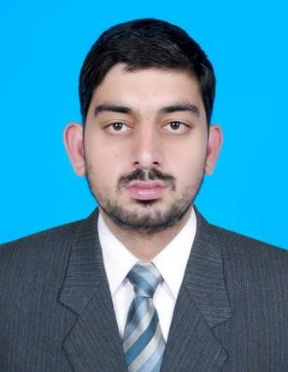

Objective:

To prolong my professional career in strenuous and dynamic environment of an outstanding and famous organization which will provide me chance to enhance my applied knowledge and polish my technical skills.

Professional Experience:

Pakistan
Assistant Surveyor Dec 2014 to Dec 2017

Responsibilities:

- Planning of the technical visits; scheduling the work;
- On site meeting (technical visits);
- Supervising sites, controlling work quality, attending in acceptance;
- Monitoring of the process in order to meet the quality standards of the work carried out by our company and sub-contractors;
- Validation of the documentation after technical visits;
- Evaluation of plan, drawings and sketches;
- Attend meetings and discuss project details with clients, contractors, asset owners and stakeholders;
- Perform drafting according to specifications; ensured compliance with all project quality procedures and requirements;
- Wrote weekly quantity reports for soil volumes to track progress and invoice clientele;
- Collaborated with project manager to maintain effective working relationships with contractors, engineers, architects and staff to achieve deadlines;
- Established accurate records, prepared reports, and provided cost and quantity estimates which lead to decreased project cost while maintaining a high level of quality;
- Generated final drawings by using CAD and visual inspection for checking accuracy.

Academic Profile:

- Passed basic estimation – quantity surveyor – 6 months course from Punjab Board of Technical Education Lahore with Grade A in 2019.
- Passed 2 papers (out of 3) of International General Certificate (IGC) from the National Examination Board in Occupational Safety and Health (NEBOSH) in 2019.
- Passed diploma in Civil Engineering from Board of Technical Education and Training with an aggregate percentage of 62% in 2012.
- Passed Secondary School Certificate (SSC) from Mirpur Board – Azad Kashmir Pakistan with an aggregate percentage of 64% in 2009.

Software Skills

- Basic Microsoft excel
- Basic Microsoft word
- Basic Auto cad

Interests:

- Reading Book | - Enjoying movies | - Talking with friends
- Using Social Websites | - Watching Talk Shows

References:

Will be provided on demand.

