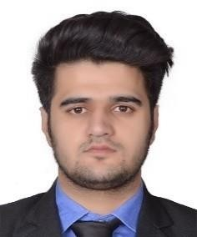

Email: sabir-394506@2freemail.com

CURRICULUM VITAE SABIR

Civil Engineering Professional Looking for a Challenging Position in Domains of Engineering or Business Development

Self-motivated and career focused professional interested in seeking a challenging position in a reputed organization in domains of civil engineering with exposure to diverse range of projects or business development with exposure to challenging sales/marketing roles.

Education & Training

Bachelor’s in technology (Civil), Christ University, Bangalore, India (2019)
Certification in Building Information Modelling (BIM), Christ University, Bangalore, India (2019)

Professional Experience

(BANGALORE, INDIA) MAY 2018

SITE ENGINEER

Responsible for site supervision and coordination with MEP team for construction of G+20 Residential Apartments (Client: Total Environment, Project: Learning to Fly).

Slab and Column Level Checking.
- Bar Bending Schedule.
- Reinforcement Checking for Columns, Slabs and Beams.
- Concrete Calculations for Slabs, Columns and Footings.
- Shuttering / Form Work Calculation.

(SRINAGAR, INDIA) APRIL–MAY 2017

SITE ENGINEER

Part of project team responsible for construction of Flyover in Srinagar City.
- Site Engineer responsible for Piling work execution and Concrete calculations.

Reinforcement Checking.
- Form Work Calculation.

Workshops & Professional Seminars
Bridge Design by Civil Simplified Traffic Simulation by Civil Simplified
Construction Management using Primavera P6 by Civil Simplified Waste Water Treatment & Water Resources by Ashoka Trust (ATREE) Urban Planning by IDES Consulting
Construction Management by Synergy Property & Development
Publicity Head for Magnovite 2017 and 2018 (Annual Techno-Cultural Fest) Student Member for Indian Concrete Institute

Languages

English (Fluent) Urdu-Hindi (Fluent)

Computer/IT Knowledge
Microsoft Suite Auto Cad
BIM
Staad Pro E Tabs
Primavera P6 Archi Cad

Skills, Competences, and Interests

Team Player
Multitasking, Quick Learner and Positive Attitude Strong Interpersonal Skills

Personal Details Gender: Male Nationality: Indian
Date of Birth: 10th October 1996

