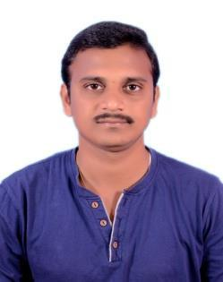

RESUME

VASU Mail: vasu-394519@2freemail.com

Career Objective

To achieve a sound position in the corporate world and work enthusiastically with a team to achieve the goals of the organization.To seek challenging assignment and responsibility, with an opportunity for growth and career advancement as successful achievements.

Experience

- Working as Spare Parts Executive
- From 01-01-2018 To 14-07-2019. (1 year 6 months and 14 day's)

- Working as workshop supervisor in Vijayawada From 08-05-2017 to 25-12-2017. (7 months)

- Working as service advisor (Accounts, supervisor & Purchase Dept.) in

Al-Qusais (DUBAI) From May’2013 to January 2017.(3years 9 months)

- Worked as Students In-Charge in Hydernagar from Jan’2012 to March 2013 (1year 3months)

Job Description

- Employees in this job serve as supervisors for coordinating and directing subordinate automotive mechanics, semi-skilled workers, and trade helpers,responsible for the

operation,coordination, and quality control of a garage, or acts as assistant in a large departmental garage, or serves as repair supervisor in the state motor pool garage, or acts as a district equipment inspector.

There is a one classification level in this job.

Auto Mechanic Supervisor

The employee functions as first-level supervisors with responsibility for coordinating and directing subordinate automotive mechanics, semi-skilled workers, and trades helpers, responsible for the operation, coordination and quality control of a garage, or acts as assistant a large departmental garage, or serves as repair supervisor in the state motor pool garage, or acts as a district equipment inspector. The employee diagnoses difficult repair problems and provides training in skills such as hydraulics, diesel engines ,welding, and fabrication of parts and tools.

JOB DUTIES

Evaluates and verifies employee performance through the review of completed work assignments and work techniques.

Identifies staff development and training needs and ensures that training is obtained.

Ensures proper labor relations and conditions of employment are maintained.

Academic Qualifications

- ITI (Electrical& Electronics)

PVCHR & KITC college,Jangangudem With 93%. ( 2011 )

- Secondary School Certificate(SSC)

ZPH SCHOOL, from Board of Secondary Education With 55%. ( 2006 )

Technical Qualification
Application Software’s |  | : MS OFFICE
Personal Profile
Date of Birth | : 29-06-1991
Sex | : | Male
Languages Known | : | English, Hindi and Telugu

Declaration

I hereby declare that the above-mentioned information is correct up to my knowledge and I hear the responsibility for the correctness of the above-mentioned particulars.

(VASU)

