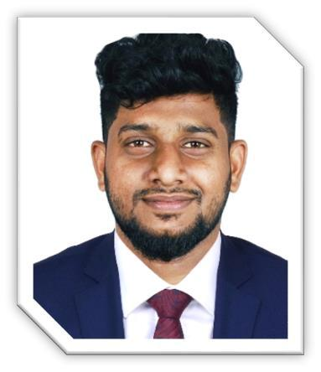
ASIF
Senior Sales Executive

PERSONAL INFO

Nationality: Indian

Marital Status: Married UAE D/L: Valid

DOB: 29-APR-1987

WORK EXPERIENCE 8 Years

Senior Sales Executive March 2018- Present

At Business bay, Dubai Responsible for selling all types of electronic consumables. Representing the company in various exhibitions and trade fairs. Researching the market on a regular basis for related products. Monitors competition by gathering current marketplace information on pricing, products, new products, delivery schedules, merchandising techniques, etc. Helps to achieve revenue growth and profit.

Overall execution and Controlling of online sales also (Noon.com

Amazon, etc. Detailed sales forecasting.

Sales Executive January 2014- Dec 2017
In Dubai

Selling of Electronic Gadgets, Mobile phones, Mobile Accessories, fulfilment center, security cameras, lightings, Mini pcs etc.
Deals with export of products, price negotiations analyzing stock details and take appropriate actions. Maintained and exceeded all selling requirements including sending QTN accepting PO's on time and all QN’s processed on time

Business Development Executive Oct 2011- Dec 2013

In Dubai

Sales of Mobile phones, computers and accessories from local market. Coordinate with imports team. Research and identify new marketing opportunities. Maintain fruitful relationships with clients and address their needs effectively. Work with senior team members to identify and manage risks.

PROFILE

To work in a position where I will increase gains in profit performance, revenue growth and market share by using my expertise and skills in business management and entrepreneurial drive. Well knowledge of UAE Market conditions especially Dubai market is my key strength.

SKILLS

Vendor Mgt

Forecasting

Direct/

Online Sales

MS Office

Negotiation

AWARDS/INTERSETS

- Best performer award from E trends general trading LLC.

- Football - School/College Team Current affairs& Travelling.

LANGUAGES

English

EDUCATION | Malayalam
2008-2011 Bachelor of Commerce | Hindi
Calicut University, Kerala-India | Arabic

CONTACTS

Asif-394524@2freemail.com

Villa 32, Street 15 A
Rashidiya- Dubai

