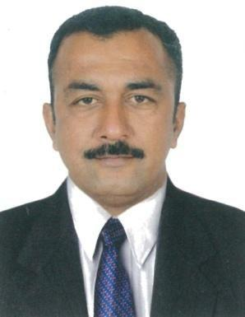
HIMANSHU

E-mail ​:-​ himanshu-394534@2freemail.com

To work in a position where I will increase gains in profit performance, revenue growth and market share by using my expertise and skills in business management & entrepreneurial drive and also seeking challenging assignment in sales & marketing operation, business development and channel management in banking, telecom or consumer durable industry and fact.

Core Competencies

    - Sales & service operations

    - Distribution / channel management

    - Team management

    - Computing skills

I. Entrepreneur - Ahmedabad (From 2017)

II. Pilot Sales Executive : north Gujarat composing of one district for 7 years.
Roles and Responsibility :-

- Drive sale initiatives & achieve desired targets with overall responsibility of ROI.

- Map and analyses business potential, identify new profitable product and product lines.

- Identify and explore new markets & top profitable business opportunities.

- Develop and sustain the existing network and effectively manage the supply chain.

- Expand the dealer infrastructure and appoint new partners in untapped markets.

- Evaluate performance & monitor distributor sales and marketing activities.

- Handle distribution and depot accounting.

- I know brand channel penetration in my covering all areas.

- Motivate, mentor, guide and monitor distributors to achieve goals.

- Impart training to new distributors and create awareness on product.

- Display the sales and marketing activities plan for front liners with target setting and reviewing measures.

Sales Executive :-​ Ahmedabad (India) Ltd for

  - years.

Roles and Responsibility :-

- Built relationship with distributors and monitor the network of stockiest.

- Increase the Nestle sales.

- To achieve the given target of sale.

- To make growth increase every month.

- To display the Nestle product in a creative way to increase the sales of respective Nestle product.

- B.Com from Gujarat University - India.

- Having good knowledge of M S Office.

- Good ability and skill to create awareness of respective product.

- W D S System

- Any desk

Date of Birth : 13/ Aug/ 1977
Sex : Male
Marital Status : Married
Languages Known : English, Hindi, Gujarati
Hobbies : Driving, Travelling, Reading

Declaration:-

I solemnly declare that the all the above information is correct to the best of my knowledge and belief.

​
Himanshu

