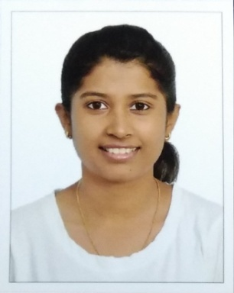
Sneedhi
Dubai UAE
Date of Birth: 12 November 1996
Email: sneedhi-394538@2freemail.com
Marital Status: Single
Nationality: Indian

CAREER OBJECTIVE
- To achieve a successful and a challenging position in a growing company and to utilize my knowledge for the betterment and growth of the organization.

KEY SKILLS
- Analytical skills
- A keen observer
- Quick learner

PROFESSIONAL EXPERIENCE

in Goa as an apprentice in Quality Assurance department.
October 2018 – August 2019

- To follow the basic norms of CGMP and Health, Safety and Environmental norms.
- To operate Cipdox – Document Management System based on the roles and rights provided in the application.
- To carry out line clearance for equipment/area.
- To carry out in-process tests for batches under manufacturing.
- Ensure line clearance, overprinting proof checking and other controls related to batch manufacturing and packing areas.
- Audit trail review of the equipments.
- Review of executed batch manufacturing records.
- Approving/ rejecting of EMCM, EMRM.
- Ensure proper cleanliness and maintenance of department, premises and equipment.
- Ensure status labeling in the area.
- To ensure that the required initial and continuous training of department personnel are carried out and adopted according to need.
- Documentation and upkeep of files related to training.
- Periodic review of training records.
- Issuance and review of bound books and Master annexures.
- Review logbooks.
- Retention and Destruction of documents and records as per SOP.
- Review of implementation, updations, review and continuous improvement of SOP’s and system as per recent revisions in CGMP guidelines.

in Belagavi as an intern. June 2018 – July 2018

- To follow the basic norms of CGMP and Health, Safety and Environmental norms.
- Worked in Quality Control and Production department.

ACADEMICS
Qualification | School / College | University / Board | Year of Passing
Bachelor of Pharmacy | KAHER College of Pharmacy | KLEU Belagavi Karnataka | 2014 - 2018
(Higher Secondary School) H.S.S.C | Cuncolim United Higher Secondary School, Cuncolim-Goa | Goa Board | 2014
(High School) S.S.C | The New Educational Institute, Curchorem-Goa | Goa Board | 2012

SOFTWARE SKILLS
- Proficient in Microsoft Office with the best knowledge of excel, word and powerpoint.

EXTRA CURRICULUM
- Participated in school/college level sports.
- Participated in college events.
- Participated in National Cadet Corps (NCC) camps.
- Served for Indian Red Cross Society.

LANGUAGES KNOWN
- English | - Hindi
- Konkani | - Marathi

Visa Status (Visit Visa)
Until 15 December 2019

