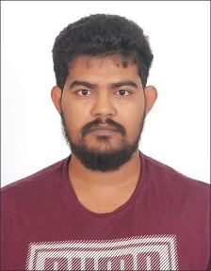
Ruman
Address: Sharjah, UAE.
Email: ruman-394550@2freemail.com

Objective
To be a part of an esteemed organization where I can learn, develop and utilize my skills.

Education
B.Sc. (Applied Sciences) in Mechanical engineering with 3.23/4.0 CGPA from
International Centre for Applied Sciences, MAHE, Manipal.
Higher Secondary school Certificate(Science) with 65.67% from
CHM College of Arts, Commerce and Science, Maharashtra State Board, Ulhasnagar.
Secondary School Certificate with 85.07% from
Carmel Convent High School, Maharashtra State Board, Badlapur

Skills and interests
- Organized and detail oriented.
- Disciplined and focused.
- Fast learner with a positive attitude.
- Willing to work in a challenging and a dynamic environment.
- Strong written and verbal communication skills.
- Fluent in English, Hindi and Marathi.
- Technically proficient in MS Word, Excel, PowerPoint and AutoCAD.
Interests: Soccer, Music, Gaming, Stock Market, Politics and reading books.

