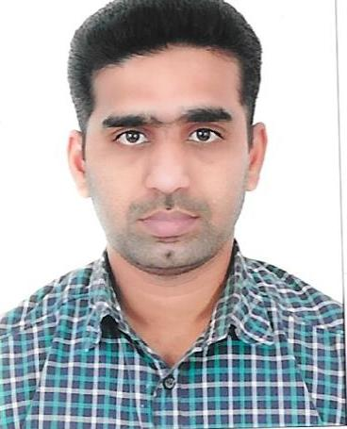

SUDEESH
B.COM
Email: sudeesh-394564@2freemail.com

ACADEMIC PROFILE
(Non Technical)
Higher Secondary education from
Kerala Higher Secondary Board,-Private Sector.

HighSchool Education from Kerala State Board, Seventh Day School,Ottapalam.

SKILLS & ABILITIES
Software known
- Applications:word,excel,powerpoint,,Acconting software -Tally EXA SYSTEM

- Operating Systems : Windows 8,7, XP, .

CAREER OBJECTIVE

To work for an organization which provides me the opportunity to improve my skills & knowledge to grow along with the organization objective. To obtain a creative & challenging position in an organization that gives me an opportunity for self improvement& leadership, while contributing to the symbolic growth of the organization with my technical, innovative & logical skills.

WORK EXPERIENCE
COMPANIES
- THANGALOOR ,THRISSUR . ( YEAR 2009- 2010 )

- KADAVANTHRA , COCHIN (YEAR 2010-2011)

- OTTAPALAM , PALAKKAD . (2011-2014)

- RIYADH , SAUDI ARABIA (2014 TO PRESENT )

POSITION HELD :
- Accounts Assistant ,
- Accountant,
- Sales Assistant,
- Operation Manager,
- Warehouse Handling ,
- Freight Forwarding Section Experience .

NATURE OF DUTIES
- Preparing schedule of monthly activities as per the target.
- Organizing the day to day activities in Accounts .
- TECHNICAL PROFILE

Degree :BACHELOR OF COMMERCE
University : Calicut University
College : Vivekananda College (Private Sector )
Year : 2005 - 2008

Languages known
- English (read, write, speak)
- Tamil( speak)
- Malayalam(read, write, speak)
- Arabic ( Understand)

- Supervising of Employees .
- Supervising of Employees .
- Freight Forwarding Section Handling
- Customs Clearance Handling
- Supervising of Employees
- Freight forwarding section Handling
- Supervising of employees
- Customs Clearance Handling
- Assisting the officials in the various certification inspections by government authorities

PERSONAL PROFILE
- Date of Birth :15.11-1987
- Gender :Male
- Marital status : Single
- Driving License : Indian / Saudia

DECLARATION
I SUDEESH.K.R declare that the information furnished above is true to the best of my knowledge and belief.
SUDEESH

