CURRICULUM VITAE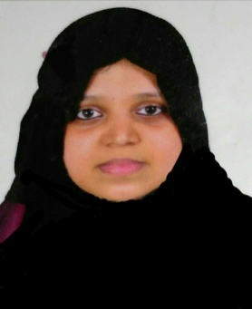

FIJIDA
E-mail id: fijida-394576@2freemail.com

OBJECTIVE: Seeking a challenging and rewarding opportunity in the medical coding field which can provide me the space for my career growth along with the company.

Education and Certifications:

- Master of Science (M.Sc) -Calicut University,2009
Specialization-Biotechnology

- Certified Professional Coder (CPC-A) from Aapc (American Association of medical coders).

- Computer skills- Microsoft office

- Language proficiency-English ,Hindi, Malayalam

Work Experience:
1.Medical coder- UAE
In Al Ain(present)

Job responsibilities:
In patient coding:
1. Proper analysis of patient files to determine the type of coding as DRG, 24 or 25 cases.
2. Detailed study of case including doctors progress notes, nursing notes, and other diagnostic reports to determine the DRG level using 3M software.
3.Arising queries wherever required to ensure coding is completely in compliance with the documentation provided.
4.Assisting the approval team related to coding.
Out patient coding:
1.Responsible for assigning correct diagnosis and procedurecodes according to Abu Dhabi DoH rules.
2 Assisting insurance billing teams in timely submission of claims .
3. Coordination with approval team for providing correct codes for pre approvals.
4.Handling calls from doctors and other ancillary staff related to coding.
Specializations:
Internal medicine, Ob gynecology,Pediatris, Orthopaedics, General surgery, Urology...
2. Insurance coordinator- UAE
In Dubai( March 2018- May 2019)

Job Responsibilities:
1.Verification of received medical documents including doctors report , nursing reports, laboratory and radiological results etc and make sure they support each other.
2. Assigning proper ICD, CPT and HCPCS codes for the diagnosis and servicesprovided.
3.Arise queriesto the physician or other departments wherever required.
4. Ensure all coding practices are accurate and in compliance with DHA andHAAD rules.
5. Ensure proper documentation of all activities.
6.Empanelment works for new medical center.

3.Exposure to Tasneef auditing
1.RepresentedEscrow medical billing services for the Tasneef-Rina audit of their client Family Emirates Home Nursing on 7th March 2019.
2. Represened Escrow medical billing services for the Tasneef- Rina audit of their client Medscope Medical Center on 22 May2019.

Personal Attributes:

- Good knowledge on medical coding guidelines and techniques- ICD~10-CM, CPT and HCPCS Level II.
- Enthusiastic and quick to learn.
- Good interpersonal and organisational skills
- Ability to perform under pressure.

PERSONAL INFORMATION:

Date of birth : 14-06-1986
Sex : Female
Marital status : Married
Nationality: Indian
Visa Type: Husband’s sponsorship

