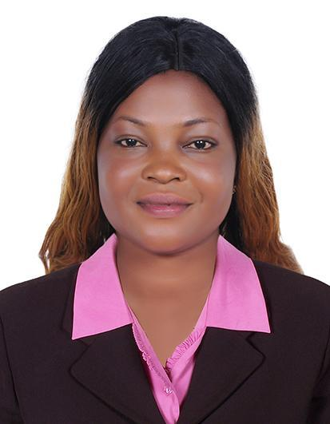
CURRICULUM VITAE
FOLASHADE
DUBAI, U.A.E
VISA: Visit Visa
NATIONALITY: Nigerian
LANGUAGE: English
EMAIL: folashade-394577@gulfjobseeker.com
SUMMARY PROFILE

- Bank teller with over 4+ years of experience maintaining cash drawer, handling customer transactions, cross-selling bank products, and keeping customers happy by providing professional, efficient service
- Customer service expert, often being tasked to deal with tricky clients both in person and over the phone
- Capable of using quicken &other forms of banking software, proficient with the Microsoft office suites, and excel.
- Won customer service of the year award in 2016 at my BOA branch

SUMMARY SKILLS

- Ability to type 80 WPM
- Data entry skills problem solving adaptability collaboration
- Excellent mental math ledger balancing cash handling
- Loyal and dedicated employee with an excellent work record.
- Enthusiastic, Knowledgeable, hardworking and eager to meet challenges
- Responsible, dependable and open to new ideas
- Easy adapting to new cultures and able to work in a multicultural environment
- Energetic, positive attitude
- Problem solving skills
- Multi-tasking skill
- Up-selling
- Micro-soft office proficiency
- Fluent in English

WORK EPERIENCE 1

NIGERIA 2015/2017
Cashier

- Greet customers when entering or leaving the store
- Maintain clean and tidy checkout areas
- Track transactions on balance sheets and report any discrepancies
- Handling petty cash and verifying expense.
- Maintains accounting ledgers by verifying and posting account transactions.
- Balance automated tellers machine, teller cash dispensers and recyclers frequently eclipsing $125,000
- Process on average 20+ customer transactions per hour during peak period
- Handled cash transaction in excess of $20,000 a day
- Connected customers with investment bankers when requested
- Resolve customer complaints, guide them and provide relevant information
- Answer Customers questions, and provide information on procedures or policies.
- Receive payment by cash, check, credit cards, vouchers, or automatic debits.
WORK EPERIENCE 2

LAGOS, NIGERIA 2017/2019
Cashier
- Handle merchandise returns and exchanges
- Managing transactions with customers using cash registers
- Scanning goods and ensuring pricing is accurate
- Issue receipts, refunds, change or tickets
- Redeem stamps and coupons
- Resolve customers complaints, guide them and provide relevant information
- Manage transactions with customers using cash registers
- Collect payments whether in cash or credit
- Offer customers carry-out service at the completion of transactions.
- Compute and record totals of transactions.
- Cash checks for customers
- Issue receipts, refunds, credits, or change due to customers.
- Keeping track of all payments and expenditures, purchase orders, invoices, accounts statements.
- Count money in cash drawers at the beginning of shifts to ensure that amounts are correct and that there is adequate change.

ACADEMIC QUALIFICATION

National Open University of Nigeria (Bsc Accounting)
Igbajo Private Polytechnic, Igbajo (National Diploma) Accounting

