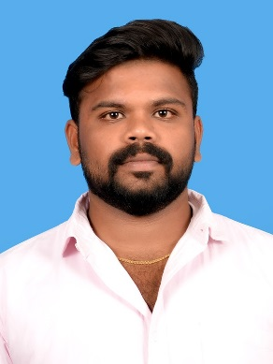
CURRICULUM VITA
SATHISH
Email Id: sathish-394580@gulfjobseeker.com

CAREER OBJECTIVE:
To pursue a challenging career in an esteemed organization where I can showcase my extensive knowledge of engineering principles, theories, specifications and standards.

EDUCATIONAL QUALIFICATION:
Course | Name of the Institution | Board | Year of Passing | Percentage (%)
Diploma in Mechanical Engineering | Arulmigu Senthilandavar Polytechnic College | Directorate of Technical Education | 2014 | 89
S.S.L.C | H.N.U.C Higher Secondary School | State Board | 2009 | 73

WORK EXPERIENCE:
Position | Duration
 | From | To
Apprentice Trainee | 01.07.2014 | 01.07.2015
Designing Engineer | 01.08.2015 | 09.11.2016
Maintenance & Technician Leader | 12.03.2017 | 04.05.2019

JOB FUNCTIONS & KEY RESPONSBILITIES:
- Organized and maintained CAD files for all residential and commercial projects
- Verified dimensions and floor plans through physical inspections when necessary
- Managed all CAD designer teams within the custom residential department.
- Designed and drafted piping isometrics line drawings P&ID’s motor schematics PFD’s and cable/conduit schedules.
- Collaborated with engineering and field inspection teams to design and draft retrofit solutions for electrical and mechanical applications.
Owned crude oil production equipment projects from concept to budget to design and drafting to production

TECHNICAL SKILLS:
Software : Auto Cad, Photo Shop.
Operating System : Windows XP, Windows 8 & 10.

AREA OF INTEREST:
- Automobile Engineering.
- Thermal Engineering.
- CAD Designer
INPLANT TRAINING:
- 12 Days in “VIJAIYA Automobiles”, Tenkasi during November 2012.
PROJECT PRESENTATION:
- Fork Lifter using Hydraulic Pump.
ACHEIVEMENTS:
- Won College Level Best National Service Scheme Volunteer Award during 2012 to 2013.

PERSONAL DETAILS:

Date of Birth : 29.07.1993
Language known : English(r/w/s), Tamil(r/w/s).
Skills : Leadership quality, Adaptability
Hobbies : Playing Cricket, Hearing Music

I hereby declare that all the information given above is true to the best of my knowledge.

Place: Yours Truly

Date: SATISH

