Baderuddin

Master of Business Administrator graduate with over 8+ years of expertise in Focus ERP & Centra CRM Implementation, Business Analyst & Support Assistance.

Baderuddin-394585@2freemail.com

Key Skills |  | Profile Summary
Centra CRM Implementation |  | Manage the development and enhancement of the Enterprise Resource
 |  | Planning (Focus ERP) and Customer Relationship Management (Centra
Focus ERP Implementation |  | CRM) by defining the system application like Procurement, Inventory,
 |  | Finance & Sales, Marketing & Service Management, Real Estate
Point of Sales (Focus POS) |  | Management, Fleet Management & Garage Management System
 |  | Design architecture and interfaces of default system application like Sales,
Business Analyst |  | Marketing & Service
 |  | Gather user requirements, design workflows needed to support the
Software Development Life Cycle |  | implementation as well supervise and to ensure that the go-live is executed
 |  | within the given timeline, budgets and targets
Installation of Server & Equipment |  | Oversee development of specifications in line with defined and approved
 |  | business requirements and ensure that the solutions / configurations are
Technical Support |  | designed and usefulness
 |  | Skilled at providing Focus ERP and Centra CRM implementation and
Training Management |  | support (Procurement, Inventory, Finance, Sales, Marketing Service and
 |  | Property Management system
Team Building & Leadership |  | Implementation done on various multiple segments (Trading, Facility &
 |  | Property Management, Facility Management, Fleet Management system
 |  | etc.)
 |  | Introductory meeting with Client for planning of SRS (System Requirement
 |  | Specifications)
 |  | Understanding Client Business requirements and study of each Process
 |  | Documentation and Gaps analysis of System Required Specifications
 |  | Mapping Business Process into Focus ERP & Centra CRM System
 |  | Sending SRS Schedules and documented SRS to Client for Approval
 |  | Once the SRS is approved, preparing the Schedule for Implementation
 |  | Providing training and troubleshooting of Focus ERP & Centra CRM system
 |  | Assisting and guiding Implementers while Implementation
 |  | Solving issues while Implementation
 |  | Integrated Focus ERP software on different version like Focus RT, Focus7,
 |  | Focus8 & Focus Web
 |  | Reporting the progress of Implementation to the Senior Management
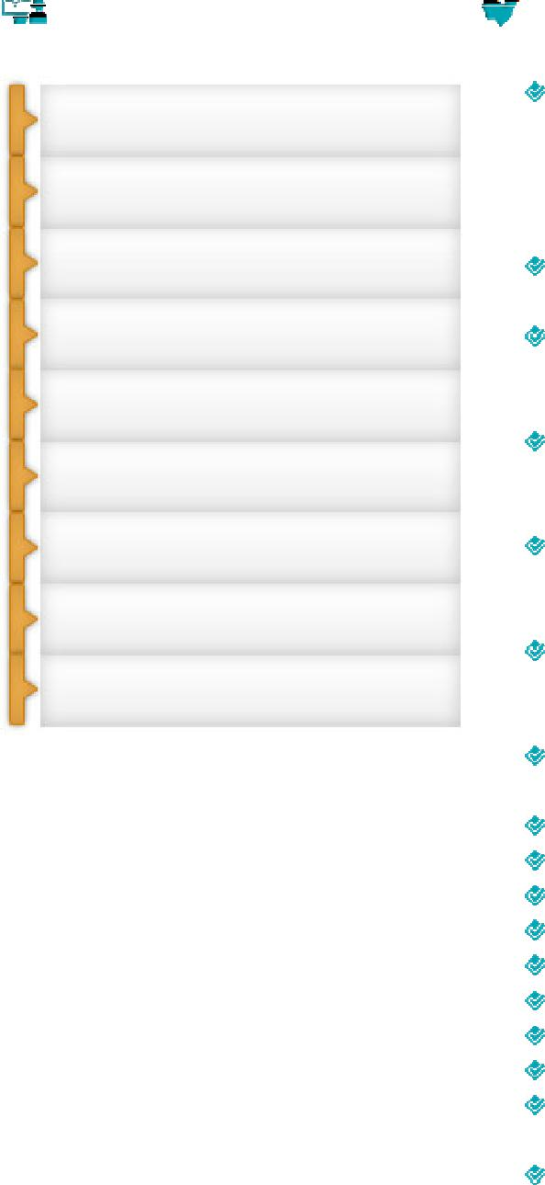

Career Timeline

 |  |  |  | , | Singapore
Hyderabad Marketing (Distributor |  |  | India | as a | as a Senior ERP Consultant | &
for FMCG | Hyderabad,
 | products) Hyderabad, |  | Support |  | Business Analyst
 | Customer
India as a System Administrator
 | Executive
2004 - 2007 | 2007-2010 |  |  |  | 2012 - 2013 | 2013 till date

2010-2012

Doha,
Qatar as a Senior CRM & ERP

Analyst
Hyderabad, India as an

ERP Consultant

Soft Skills
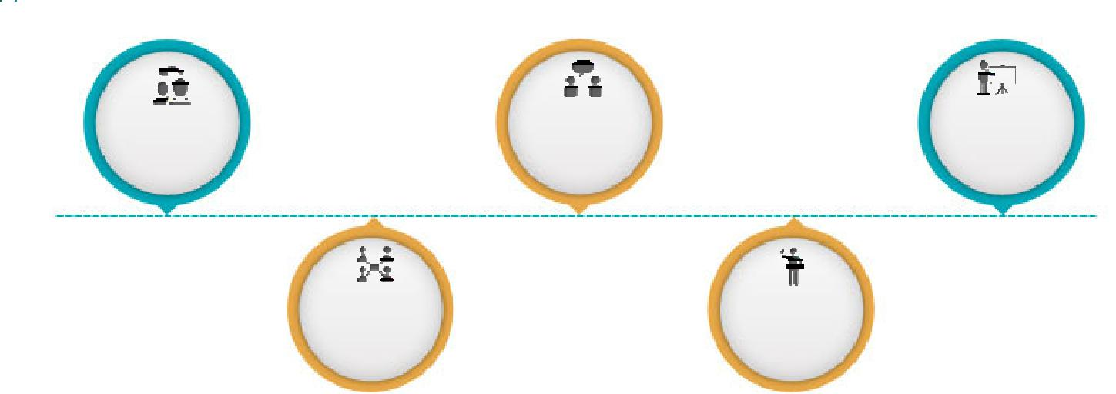

 |  |  | Communicator | Planner
Change Agent

Collaborator _{Motivator}

Work Experience
Feb’ 2013 till date
Doha, Qatar as ERP & CRM Implementation & Analyst

Role:

Performing full performance level work, analysing, refining and documentation the business requirement of customer included in the development , Implementation and production of Customer Relationship Management (Centra CRM) and Integrated Enterprises Resource Planning (Focus ERP)

Create functional and technical specification for Focus ERP system to meet business requirement while ensuing the Integrity of the technical flow design using Visio

Understanding the Business requirement and study of each business process Documentation and Gaps analysis of system requirement study (SRS) / Business requirement documents

Implementation of Focus ERP / Centra CRM system based on the Client’s requirement

Mapping Business Process flow into Focus ERP / Centra CRM system Solving issues while Implementation

Implementation done on various multiple segments like (Trading, Manufacturing, Production, Engineering and Iron & Steel Etc.)
Reporting the progress of Implementation to the Senior Management

Designing reports in Focus ERP & Centra CRM as per the requirements provided by client using in-build reporting tools

Achievements

Delivered the

delayed project

of Focus ERP

implementation

Setting up,

designing,

customizing on

Focus ERP &

Centra CRM

Conducted

User’s training

of 30 resources

Implementation

and Support

Assistance

Feb’ 2012 – Jan’ 2013
Singapore as Senior ERP Consultant & Business Analyst

Role:

Understanding the Business requirement and study of each business process Documentation and Gaps analysis of system requirement study (SRS) / Business requirement documents

Implementation of Focus ERP system based on the Client’s requirement Mapping Business Process flow into Focus ERP system Solving issues while Implementation
Reporting the progress of Implementation to the Senior Management

Designing reports in Focus ERP as per the requirements provided by client using in-build reporting tools

Aug’ 2010 – Feb’ 2012
Hyderabad, India as ERP Consultant

Role:
Implemented of Focus ERP system based on the client requirement
Installation and maintained Focus ERP system for functional accounting purpose.
Developed and executed ERP system programs.

Participated in understanding of functional specifications and business requirements
Supported product customizations and suggested ERP upgrades
Conducted training sessions regarding Focus ERP system processes
Documented business process flows and configured Focus ERP system application
Reviewed and reported customer requirements for gap analysis.

July’ 2007 – July’ 2010
, Hyderabad, India as Customer Support Executive

Role:

Implementation of Wings Accounting Software at Client’s place Providing training and trouble shooting of Wings Software Understand & map client's requirements and provide solutions. Revenue Generation through up gradation and ASC collections Meeting deadlines without compromising quality norms

Participating in proposal discussions, negotiations and follow-up till successful closure of the deal

Sep’ 2004 – June’ 2007
Hyderabad, India as System Administrator

Role:

Administrating the Wings 2000 Pro (A/c & Inventory Software) Training new recruits in the organization on Wings Trouble shooting

Technical Skills:
Database Tools:
Microsoft SQL Server2005, 2008, 2008 R2, 2012R2 & 2014

Enterprises Technology:
Microsoft Dynamics , Focus ERP & Centra CRM

Certification

Education

Personal Details

Achievements:

Successfully delivered the delayed project of ERP implementation by gathering functional requirement of all the modules and was acknowledged for the same Credit of setting up, designing, customizing Focus on ERP system as Project Lead Conducted User’s training of 30 number of resources on Proper usage of ERP

Diploma in Computer Application (DCA) in MS Office & Accounting Packages Diploma in Hardware Engineering & Networking
Course Certificate in Microsoft Dynamics CRM from Aads Education

Master of Business Administrator (M.B.A.) in 2005 B.Com. from Osmania University, Hyderabad, India in 2003

Intermediate from Board of Intermediate Education, Hyderabad, India in 2000 10th (SSC) from Secondary School Certification in 1997

Date of Birth: 4th April 1981
Nationality: Indian
Passport Details: Expiry (28th January 2025)
Visa Details: Residence Visa - Focus Sponsorship (Company)
Driving License Details: Qatar & India
Marital Status: Married
No. of Dependents: 2

