MR. YOGESH
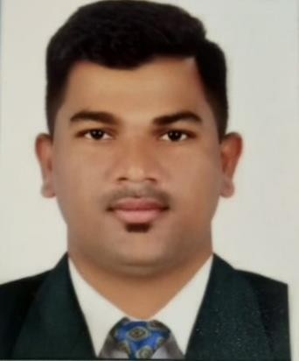

Email address: yogesh-394595@2freemail.com

CARRER OBJECTIVES:

- To start with customer service field through a well established firm that will give me more exposure to different markets, in order to enhance my skills and help utilize myself resources in the best possible way. Accomplishing the highest possible returns on the both the firm and personal levels through team interaction.
- Seeking a challenging position in a reputable company where my academic background and interpersonal skills are well developed and utilized.

PERSONAL DETAILS:

NATIONALITY : INDIAN
DATE OF BIRTH : 26TH OCT, 1989 RELIGION : HINDU MARITAL STATUS : MARRIED GENDER : MALE
VISA TYPE : VISIT

EDUCATIONAL BACKGROUND:

COLLEGE : MUMBAI UNIVERCITY
2008

HIGH SCHOOL : High School Certificate
Year – 2005

SKILLS/QUALITIES:

Responsible and flexible Hardworking
Self motivated
Work effectively with diverse group of people Good command of speaking and written English
Computer basic knowledge and other related information processing through

online/internet
Basic in computers MS-CIT (Ms Word, Excel & Operating internet)

WORK EXPERIENCE:

  - Worked in Clothing/Garments company As Sales Executive for the period of 1 years
in Mumbai.(2009-2010).

  - Worked As Sales Executive for the period of 3 years in Mumbai.(2010-2013).

  - Worked in a Car dealer(Used Cars) As Sales Executive for the period of 3 years in the Mumbai.(2013-2016).

  - Worked with Car Dealer (Used Cars) As Sales Executive For the period of 8 months in the Mumbai ( Jan To August 2017).

  - Currently working in a Credit Card Solution As Field Verification Officer
In the Mumbai, till date.

DUTIES AND RESPONSIBILITIES:
- Creating clients data base.
- Make a good relation with all customers.
- Solving problems
- Work under pressure
- Able to work in a team

DECLARATION:

I hereby declare that the above information furnished is true & correct to the best of my knowledge

Place:

Date:

YOGESH

