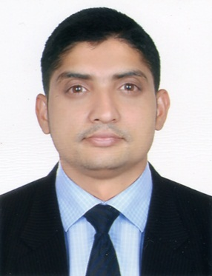
NAMSHID
Email: namshid-394600@2freemail.com

DUBAI-U.A.E

OBJECTIVE

To attain the challenging posting in the related filed to work in an organization where I can enhance my skills and contribute to the growth of the origination as well as I assure you that I will work with full of my sincerity and do justice my job and the organization.

PERSONAL DETAILS

NAME : Namshid
NATIONALITY : Indian
GENDER : Male
DATE OF BIRTH : 28/04/1988
MARITAL STATUS : Single
VISA STATUS : Visit Visa

EDUCATIONAL ATTAINMENT

- HIGHER SECONDARY SCHOOL
- BASIC KNOWLLEDGE IN COMPUTER (MS Office)

LANGUAGE

- English, Arabic, Hindi, and Malayalam

WORK EXPERIENCE

- Working as a Office Boy From 2017 to 2018 in a Business Center in Business Bay DUBAI –U.A.E

- Worked as a Salesman From 2016 to 2017 in a SUPER MARKET in KARAMA DUBAI –U.A.E

- Worked as a Salesman From 2007 to 2013 in a SUPER MARKET in BUR DUBAI –U.A.E

- Worked as a Steward From 2013 to 2016 in a HOTEL and APPARTMENT in BUR DUBAI - U.A.E

DUTIES

- Managing the sales process for new prospects, from initial contact through to closure.
- Dealing with customer enquiries face to face, over the phone or via email.
- Contacting prospective customers and discussing their requirements.
- Reporting business trends and area performance to the National Sales Manager.
- Developing & maintaining successful business relationships with all prospects.
- Identifying what customers want.
- Developing a full understanding of the business market-place
- Perform other tasks as assigned by your Manage
- Outdoor sale Executives

STRENGTHS

- Good communication skills
- Excellent attention to detail
- Ability to work independently and work in a team
- Able to respond quickly in emergency situation

REFERENCE

I hereby attested the accuracy of information declared above are true and correct the best my knowledge and belie

NAMSHID

