CURRICULUM VITAE SURESH

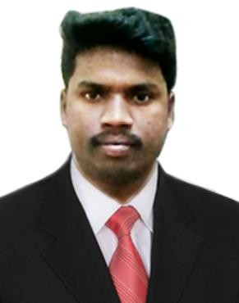  E-MAIL  Suresh-394603@2freemail.com  DATE OF BIRTH  June 2,1989  NATIONALITIES  Indian Hindu  LANGUAGES  Tamil English Hindi  COMPUTER KNOWLEDGE  Basic Computer Data Entry  MS Word MS Office Page Maker Photoshop Corel draw  OTHER SKILLS  Printing Knowledge Graphic Designing  INTERESTS  Reading Books Internet Surfing Listening Songs | OBJECTIVE  To pursue a challenging career in a reputed institution that would offer me immense opportunity to boost my career path and simultaneously make use of my skills and abilities for the growth of organization.  EDUCATION  On Going - Barathidasan University, Trichy.  BA English (Distance Education),  2006 to 2009 - Bangalore City College, Bangalore.  D.T.Ed (Diploma In Teacher Education),  WORKING EXPERIENCE  2018 to 2019 - Working in a Diesel engine dealer  (From 29th March 2018 to 29 May 2019)  Office boy.  Office Boy  Photocopying and Scanning of document Tea and Coffee Making  Cleaning Maintaining  2017 to 2018 -  Marina in Dubai. (From 5 March 2017 to 31 January 2018)  Office Assistant Cum Assistant Document Controller.  Office Assistant Document Handling Answer Telephone Calls Filling Paper  Spiral Binding  Typing documents and report and Correspondents Scan and copy making  Store Room Keeping  Maintaining the Stationary things Tea and copy making  Assistant Document Controller Receiving and Filling of document Meeting Room Arrangement  E-mail Circulation  Prepare and delivery of transmittal Photocopying and Scanning of document  2017 to 2018 -  Part time Job (From 25 May 2017 to February 2018)  Office Boy (Part time for 3 hours) Photocopying and Scanning of document Tea and Coffee Making  Cleaning Maintaining

2015 to 2017 - in Kallakkurichi

DTP Worker, Design & Print Maker
Exposing Invitation Print Visiting Card Print T shirt Print Textile Print,
Textile shop Bag Printing Customer Consultant Order Delivering

2014 to 2015 in singapore.
Internship Course (October 30, 2014 to January 30, 2015)

Cleaning Team Leader Floor Maintaining Dustbin Maintaining
Door & Washroom Maintaining Walls & Pillar Dust Maintaining Parking area Maintaining Marbles & Exalter Maintaining

Technical Skills

Typing Skills MS Word MS Excel
Adobe Page maker Adobe Photoshop Corel draw

Personal Skills

Ability to handle telephone calls, Ability to handle email and fax
Good verbal and written communication
Organization and planning skills Quick analyzing skills

Strength

Declaration
Creative Presentation Hard working Leadership Qualities Managerial Skills

I hereby declare that all the above given particulars are true the best of my knowledge and belief.

Place: Yours Cordially

Date : SURESH

