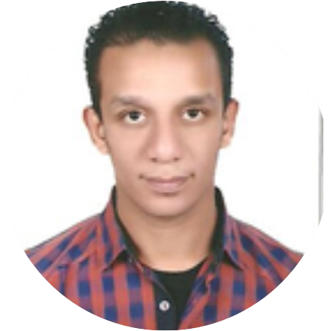

Competences
TAREK
SERVICE ADVISOR

Profile
More than 6 years in cars field and looking for new challenge

Experience

 Reading

Learning
 Interested about getting information about cars

2009 - 2009

2010 - 2011

2013 - 2015

2015 - 2016

2016 - till now

2017 - 2017

Education

Trainer, Giza
Description of the job, position and responsibilities.

Trainer, city
Description of the job, position and responsibilities.
Workshop Engineer, Cairo Managing, following up workflow

Service Advisor, Cairo
Receiving Customers and their cars
,scheduling service appointments,Writing service orders and descriptions of problems and repairs

Service Advisor, Cairo
Receiving Customers and their cars
,scheduling service appointments,Writing service orders and descriptions of problems and repairs
Egypt
Trainer, Cairo Learned About TSA21

Contact

2007 - 2011
faculty of education technology
Helwan University, Helwan

Description of the education/course.

→ tarek-394612@2freemail.com

