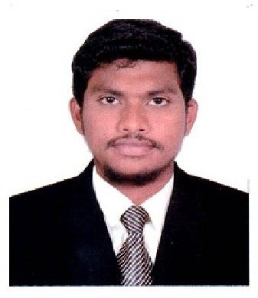 NIJAM
E-Mail Id: nijam-394635@2freemail.com

MOTIVE:

To purse career in Accounts and Finance with potential to rise to the highest echelon of Business Management.

WORK EXPERIENCE

- (IT, Security & Telephony Solution Provider)
- May 2017 to June 2019.

Major Responsibilities as an Assistant Accountant:
- Preparing Invoices and Receipts.
- Preparing Credit Notes and Vouchers.
- Preparing & Sending Statement of Accounts to Client.
- Managing Petty Cash Transactions.
- Managing Document Controller.
- Preparing VAT report for as per UAE FTA Rules.
- Maintain Day to Day Books of Accounts in Quick Book (Accounting Software).
- Maintain Bank Reconciliation Statement and Reconciliation of Debtors & Creditors.
- Maintain Journal Entry Sale, Purchase & Exp Invoice.
- Calculation of Monthly Sales Tax/Vat, Services Tax & TDS Filling Return.

- Chennai, Tamil Nadu, India.
- July 2015 to Jan 2017.

- (Part Time as an Accountant) May 2013 to Apr 2015.

Major Responsibilities as an Accountant:
- Management of Accounts & co-ordination with financial institutions for the management of funds.
- Verification of all vouchers, Posting in software & Reporting from software.
- Funds flow statement on Excel and ledgers posting in software.
- Control over Payments &Reconciliation of Vendors, Banks & others.
- Withholding tax Services & Salaries Payments, E-filing on monthly basis.
- Working with spreadsheets, sales and purchase ledgers and journals.
- Preparing statutory accounts.
- Calculating and checking to make sure payments, amounts and records are correct.
- Managing petty cash transactions.
- Controlling credit and chasing debt.

ACADEMIC QULIFICATION

- Master Of Commerce [MCOM] (2013-2015) University : Bharathidasan University, Trichy-24 Score : 65%
- Bachelor of Business Administration [BBA] (2010-2013) University : Bharathidasan University, Trichy-24
Score : 68%
- Higher secondary Certificate[HSC](2008-2010) Institution : Khadir Mohideen Boys Hr Sec School Score : 71%

PROFESSIONAL SKILLS

Operating system: Knowledge of Tally 9, Windows 7, Quick Book, Knowledge of MS-office (All packages), Dream Weaver (HTML), Knowledge of Sales Tax, TDS, Excise, Service Tax.

PERSONAL INFORMATION

Date of Birth : 15.06.1993
Gender : Male
Marital Status : Single
Nationality : Indian
Languages Known : English, Hindi, Malayalam and Tamil

Visa Status : Visit Visa until 25-Dec-2019.

- DECLARATION:

- I do hereby that declare the above-furnished information is true, correct and complete to that of my Knowledge and belief.

Your’s Truthfully, NIJAM

