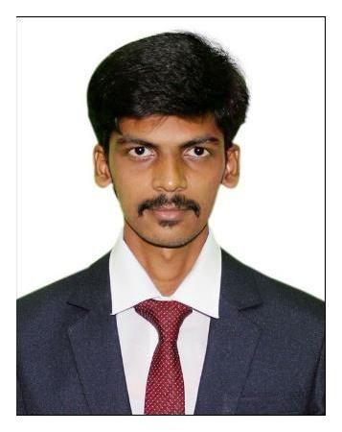

RAMEEZ
MBA [LOGISTICS AND SUPPLY CHAIN MANAGEMENT]

CONTACT

Rameez-394648@2freemail.com

ABOUT ME

Date of Birth: August 6, 1994

Age: 24

Gender: Male

Live in: Dubai

Visa Valid Date: 20th October 2019

SKILLS

Confident and determined Great at Problem Solving Ability to Quickly Create and Apply Ideas and Solutions Good Leadership Skills Critical Thinker

Positive Think

Truthful Person

EXPERTISE

Microsoft Office Package

Script language

SAP

HTML, ASP, XML

CAREER OBJECTIVE

I am Mohamed Rameez Raja who aims to be able to find an exciting and challenging entry level position in the logistics and supply chain industry alongside a company who will continuously motivate and drive me to do my best and improve on my skills and abilities in order to be able to assist the company in achieving its company mission and goals.

WORK EXPERIENCE

June 2018 To June 2019 - Junior Import, Export customer Service Cum Pricing Executive

JOB RESPONSIBILITY

- Worked as Junior Import, Export customer Service Cum Pricing Executive

- Coordinating the customers regarding the shipment, updating the customer’s shipment on daily basis and quoting the customer based on the requirement.

- Arranging Import & Export Shipments as well Import clearance shipment based on INCO Terms agreed with customer and Documents required by Indian Customs.

- As a part of pricing Team I need to contact overseas agents, Courier Company and its Agent, Airlines, Local LCL co-loaders, NVOCC and Liners to get the best rates.

- Checking Import and Export cargo Document and Issue gate in permission in custom notified Premises for Cargo Carting Purpose to the Custom House Agent.

- Issue Empty, Export Loaded, Import Loaded Container in and out

Permission. Reporting daily Movements of Container & Cargo and sent to the all CHA, Shipping Line. Update all record in system, software is “CFS

Mag”, “WHAM”.

- Document checking and finalizing through the system & sent to finance department for Invoice Preparing.

- Maintain Container & Import-Export Cargo / Container Stock in Ware House & Open Yard.

Operation System

Android Application

Technical Skills

SQL Server

C, C++

L A N G U A G E

English

Tamil

DECLARATION

ACADEMIC BACKGROUND

2016 - 2018 MASTERAL DEGREE

MBA [LOGISTICS AND SUPPLY CHAIN MANAGEMENT] University of Vels

Percentage – 66%

2013 - 2016 | BACHELOR DEGREE
 | BSC Information Technology
 | University of Bharathidasan
 | Percentage – 75%
2013 | HSC – 12TH
 | Al Ameen. Matric. Higher. Secondary. School
 | Percentage – 50%
2011 | SSLC – 10TH
 | A.R.R. Matric. Higher. Secondary. School
 | Percentage – 65.2%

PROJECT

2018 | Operation in container freight station
 | Gateway Distripark Ltd
 | Chennai
2016 | Inventory Management in Visual Basic
 | Online Software Product Sales Website in HTML &
 | SCRIPT

ADDITIONAL COURSE
₂₀₁₅ ₋ ₂₀₁₆ Honours Diploma in Computer Application(HDCA)

I do hereby assure that the above information is true to the best of my knowledge

Signature

RAMEEZ

