CURRICULUM VITAE
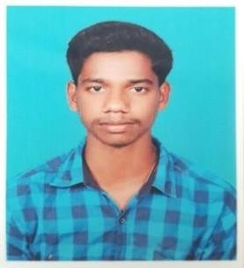
SAKTHIKUMAR
Email : sakthikumar-394681@2freemail.com

Objective :

To obtain a suitable position informs where I can utilize my skills and calibers in the tight field to tangible contribution to its growth & probability. To be part progressive organization which I can contribute my knowledge and skills as well gain experiences for the advancement of any career and development of my potential, abilities work effectively with people acquire fulfillment in the field I have choose.

Personal Details :
Date of Birth | : | 31ST MARCH 1997
Place of Birth | : | TAMIL NADU
Gender | : | MALE
Nationality | : | INDIA
Marital Status | : | SINGLE
Skill profile:
Good communication and interpersonal skill. Hard working and able to manage any shift.

Educational Qualification :
BE-Mechanical engineering Professional in product design
Software:Ansys,CATIA,GD&T and AutoCAD for mechanical engineer

Language Known :
Tamil English Malayalam
Passport Details :
Date of expire | : | 03/10/2028
Place of Issue | : | TRICHY
Visa Status | : | Visit Visa Valid till 13/12/2019
Declaration :
I sincerely hope that my application will receive your kind attention and I am most anxious that an opportunity for an interview is given to me at your earliest convenience. I hereby declare that all the information given above are true and correct according to my knowledge and believe.

SAKTHIKUMAR

