R E S U M E of Finance Professional with more than 20 Years of Experience
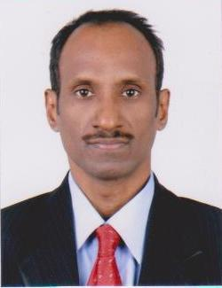

KANNAN

E-mail: kannan-394684@2freemail.com

VISA STATUS : Visit Visa

UAE Experience : 1.5 Years ( 1 Year in SAIF Zone and 6 Months in DUBAI , UAE.)

Nationality |  | : | Indian
Educational Qualification |  | : | B.Com - University of Madras, March1993
Expertise in | : Financial Accounting
 | Preparation of Financial Statements
 | VAT Compliance
 | Purchase of raw Materials (Engineering Products)
 | Imports and Exports
 | Accounts Receivable
 | Accounts Payables
 | Payroll Management
 | Customs
 | PRO
 | Office Administration
Accounting Softwares |  | : | Expertise in TALLY ERRP.9, ZOHO, Microsoft
 |  |  | Dynamic GP, ERP Next,
 |  |  | Quick Books, EPICOR & INTACCT
Strength – Language Skill |  | : | Proficient in English both Written and Verbal
D O B |  | : | 07 Oct, 1971
Marital Status |  | : | Married
Languages Known |  | : | English, Hindi, Malayalam, Telugu & Tamil

Professional Competencies

- Financial Accounting
  - Financial Accounting in a systematic manner

- VAT
  - Having hands on experience in handling VAT Compliances.

- Imports and Exports
  - Having hands on experience in handling all kinds of Imports and Exports by Air, Sea and Land

- Customs
  - Handled Customs work as and when required

- Payroll Management
  - Looking after the Payroll Management

- Accounts Receivable Management
    - Expertise in managing Accounts receivables

- Accounts Payable Management

    - Managing Accounts payables

- Commercial & Vendor Management

    - Sourced right vendors ensuring effortless and smooth business operations.
    - Kept vendors delighted while demanding high quality of services at a reasonable cost.

- Banking and Allied Functions

    - Complying to the requirements of banking and financial institutions.
    - Foreign Exchange handling

- Budget Preparation

  - Prepared Annual budgets year after year

- Financial Statements

  - Preparation of Financial statements from time to time

Experience Summary

- One year worked as Accountant employed in a Manufacturing Co in SAIF Zone, Sharjah, UAE from September – 2018 to August, 2019.

- April 2018 to September 2018 worked as Senior Accountant in Accounting firm at Deira, Dubai, UAE

- From 1994 to 2017 worked in India in various capacities in Finance and Accounts in a Manufacturing and Service company.

