SAHLA
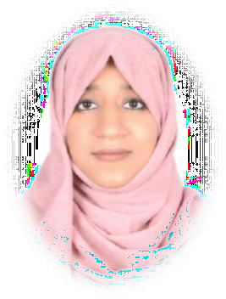

CONTACT

EMAIL:
Sahla-394692@2freemail.com

REFERENCES
Available on request.

PHARMACIST

Currently working pharmacist with excellent track record of maintaining positive relationship with customers and health care organizations.
Holding license number T3841 in MOH.

EXPERIENCE

In Ajman (pharmacist in charge)
2017–present (2 years)
- Dispensing of medicines on prescriptions as well as OTC medicines.
- Handles narcotic medicines and does well documentation of each one of them.
- Handles all type of insurance.
- Increased customer satisfaction and business revenue.
- Endow customers with information regarding the prescribed medicines as well as do proper health guidance.
- Does medicine ordering and handle the accounts of pharmacy.
- Identify and resolve therapy change and drug disease in lieu with physician.

in Kerala, India (pharmacist)

2015–2017
- Properly dispensed prescription based and OTC medicines.
- Maintained patient profit and reduced pharmacy wastage.

in Kerala, India (trainee pharmacist)

2012–2014
- Learned the work with passion and enthusiasm.
- Maintained correlation with staff and customers.

EDUCATION

Al Shifa College of Pharmacy, Calicut University, India

B.PHARM (2007-.2012)

- Passed out with first class.
- Registered as a licensee of Kerala State Pharmacy Council (reg no:46540)

Dayapuram Residential School, Kerala, India

- Did my higher secondary education. Passed with 80% result.

SKILLS

- Remarkable verbal and written communication in English, Hindi, Malayalam and Arabic.
- Appreciated customer service.
- Aware about health and health related matters.
- Keen in being updated about new medicines in the market.
- Can handle computer software easily.
- Cross-selling of medicine and related products.

