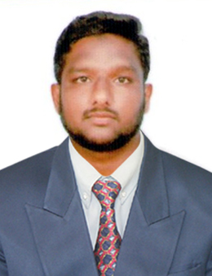  Email id:  Sowkath-394700@2freemail.com  Contact Location: Dubai  Personal Details:  Date of Birth : 07/dec/1993  Age :25 Years  Sex : Male  Religion : Muslim  Marital Status : Married  Nationality : Indian  Languages : English, Tamil  Visa Details : Visit – | SOWKATH  Career Objective:  Seeking the position of an English Teacher in an organization that will give me an opportunity to pass on my knowledge to the students in an innovative manner.  EDUCATION:  - M.A. in English Literature at Thiruvalluvar University, Chidambaram, Tamil Nadu with an aggregate of 65% passed out in the year 2017.  - B.A. in English Literature at Bharathidasan University, Trichy, Tamil Nadu with an aggregate of 61% passed out in the year 2015.  - H.S.C in Pachayappa’s Higher Secondary School, Chidambaram with  55 % in the year 2011.  - SSLC in Mustafa Higher Secondary School, Chidambaram with 65% in the year 2009.  Experience :  - Having two years of experience in handling 10th and 12th classes in Tamil Nadu.  - Having one year of experience in managing a tuition and tutorial center on my own at Parangipettai, Tamil Nadu.  - Having five month of Experience as an Assistant Professor in Department of English in Tamil Nadu.  - Having one year and two Month of Experience as a Principal at in Tamil Nadu.  Career Profile :  - To encourage creativity and higher-order thinking in a way that increases student performance.  - Possess strong analytical and problem solving skills, with the ability to make well thought out decisions.  - Excellent written and verbal communication skills.  - Highly trustworthy, discreet and ethical.

COMPUTER SKILLS

- Microsoft Word, Excel, Access, PowerPoint

EXTRA CURRICULAR

Dialectics of Diaspora Literature: Trends and Techniques

 Presented a paper with a title Diaspora Identity and Journey in JhumpaLahiri’s “THE NAMESAKE” held at JAMAL MOHAMED College. Trichy

HOBBIES

- Reading books

- Searching for new trends & techniques in Education.

OBJECTIVE
To seek a challenging and responsible position in a renowned Organization where I can prove and enhance my skills and capabilities.

DECLARATION:
I hereby declare that the above written particulars are true to the best of my knowledge and belief.

PLACE:

DATE:

Reference upon request.

(Signature)

Sowkath

