Burhanuddin
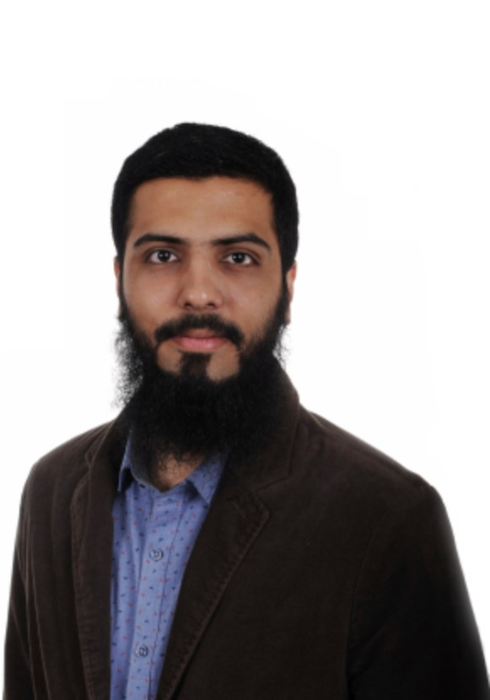
Name Burhanuddin
E-mail burhanuddin-394712@2freemail.com
Birth 16. Juli 1994
Address Dubai, United Arab Emirates

Career Summary

Education Master in International Business Administration and Foreign Trade from Germany with Major in Global Logistics and Human Resource Management.
Experience Over three years as Logistics Coordinator at Kakajee Shipping LLC in Dubai.
Responsible for handling Import / Export of LCL and FCL shipment of customers, and providing warehousing, Transportation and after sale services.
In depth knowledge in Air and Sea operations with complete documentation.

Skills In depth knowledge of customer service and experience in negotiating rates with shipping lines and achieving 100% customer satisfaction.
Punctual and self motivated individual, focused and committed towards achieving goals.

Academic education
2018 - 2019 University of Applied Sciences, Worms, Germany
Master of International Business Administration and Foreign Trade Strategies of Internationalization; International Economics; Foreign Trade Specialization: Global Logistics
2013 – 2016 UBIS University, Dubai, United Arab Emirates Bachelor of Business Administration Specialization: International Business
2010 – 2012 Center Point School, Nagpur, India Secondary School

Work Experience

2016 Jan- 2018 Jan Dubai , United Arab Emirates
Logistics Coordinator
Air freight and sea freight forwarding service;
Management of import and export process including custom clearance; Customer portfolio management;
Creating Certiﬁcate of Origin for the export and preparation of legal documents for import process;
Daily contact with customer and handling CRM; Providing warehousing & transportation services;
2015 Jan- 2015 Dec Dubai, United Arab Emirates
trainee
Freight Forwarding
Identifying new market for the business
Administration and account handling of existing customer
Providing FOB and CNF rates for the export to African and other market Free Zone Documentation
Online clearing of customs document in Dubai portal with correct usage of HS code.

Language & Skills
Languages English: Fluent (C2) Urdu: Fluent (C2) German: Basic (A1) Hindi: Mother Tongue
Computer Skills Advanced: Microsoft Ofﬁce (Word, Excel, Access, PowerPoint,
FrontPage,and Outlook),
Intermediate: Photo and Video editing (Photoshop, Adobe Creator)
Volunteer's experience Member of orphan home community (2012) (India)
Cricket coaching and organizing tournament (2014-2016) (Dubai)
Hobbies Playing cricket and volleyball Cycling
Driving License Valid Dubai Driving license

