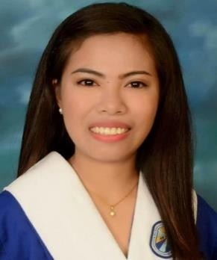
Cecille
Al Karama Dubai, UAE
Email Address: cecille-394722@2freemail.com

OBJECTIVE

To join in organization that will give me an opportunity to grow and trained, maximize my talents knowledge and skills that will lead to a career path.

SKILLS

- Conducting & facilitating and assessing Psychological Testing
- Knowledge in Psychological report.
- Proficient in MS Office: Word, Excel, and Power Point.
- Time Management EDUCATIONAL ATTAINMENT
Tertiary Education: Bachelor of Arts in Psychology
Sto. Rosario Sapang Palay College, Inc.
Brgy. Assumption, Sapang Palay, CSJDM, Bulacan. Philippines
2014- March 2018

SEMINARS AND TRAININGS
- Psychological Association of the Philippines Junior Affiliates (PAPJA) January 20&21, 2017 (SMX MOA Convention & San Juan De Letran)
- Aruga Counseling/Psychotherapy with Children Speaker: Ms. Ali Gui
February 2016 (Sto. Rosario Sapang Palay College, Inc.)
- Leadership Training Seminar
September 7, 2016 (Sto. Rosario Sapang Palay College, Inc.)
- Empowering Relationship of Drug – Free Advocates: “Drug Won’t Change You, Your Choice Will Do.”
February 22, 2017 (Sto. Rosario Sapang Palay College, Inc.) WORK EXPERIENCE
Cashier
Bulacan. Philippines (Aug – Dec 2018)
Duties & Responsibilities:
  - Greet customers when entering or leaving establishment.
  - Receive payment by cash, check, credit cards, vouchers, or automatic debits.

  - Issue receipts, refunds, credits, or change due to customers.
  - Count money in cash drawers at the beginning of shifts to ensure that amounts are correct and that there is adequate change.
  - Pleasantly deal with customers to ensure satisfaction

Guidance Counselors Assistant
Philippines (January -October 2017)
Duties & Responsibilities:
  - Assist with students’ applications and scholarships
  - Facilitate programs for drug and alcohol prevention
  - Organize peer counseling programs
  - Work on academic boards to improve learning conditions
  - Listen to students’ concerns about academic, emotional or social
problems
  - Help students process their problems and plan goals and action
HR Assistant
Quezon City. Philippines
(Dec – June 2018)
Duties & Responsibilities:
  - Assist with day to day operations of the HR functions and duties
  - Compile and update employee records (hard and soft copies)
  - Deal with employee requests regarding human resources issues, rules, and regulations
  - Coordinate communication with candidates and schedule interviews
  - Conduct initial orientation to newly hired employees

PERSONAL INFORMATION

Date of Birth October 18, 1997
Place of Birth Bulacan, Philippines
Civil Status Single
Gender Female
Visa Status Long term visa (till October 2019)

I hereby certify that the above information is true and correct to the best of my knowledge.

CECILLE

