RAKESH
Post Diploma in fire & safety engineering

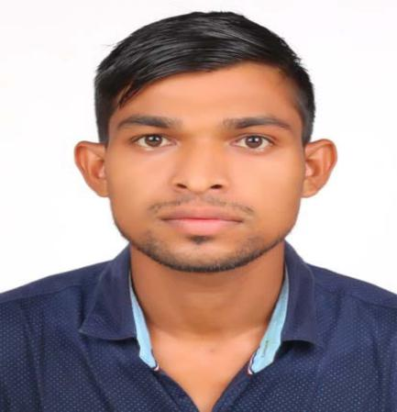
DOB: 6th July 1995 Gender: Male Marital Status: Single
Computer Skills: MS Office, Word, PowerPoint, Internet and Email
Email Id: rakesh-394730@2freemail.com

WORK EXPERIENCE

Safety Supervisor: (May 2018 to July 2019)
- Training responsibilities may involve conducting safety orientations, daily "toolbox" safety meetings.
- Knowledge of JSA (Job safety analysis) HIRA (Hazard Identification and Risk Assessment) and MSDSH etc.
- Investigating all injuries and accidents.
- Provide safety training and Enforce safety policies and rules.
- Supervises day-to-day activities within a particular construction workplace.
- Ensures that workers make use of necessary protective equipment like helmets, hand gloves, welding shades etc., where and when necessary
- Carrying out safety inspections.
- Safety inspections in locations including job sites.
- Effective communication skills.
- Ensure that all incidents are reported immediately

Safety Supervisor: (July 2017 to April 2018)
- Inspecting site to ensure hazard free environment.
- Checklist and knowledge of work permit
- Promoting safe practice at the job sites.
- Conducting Tool Box talks to workers.
- Good knowledge of store keeper and keep the record update in excel and registered.

EDUCATIONAL EXPERIENCE

2017 year: Mandavi Nagarpalika, Dist. SURAT (Apprentice) 2months
- As a student I have under gone the Apprentice by Fire Station of Mandavi Nagarpalika for period of Two Months.
- Handling emergency phone calls
- Rescue operation & fire fighting
- Maintenance of fire tender, extinguisher & boat.
OTHER OPERATIONAL ABILITY AND SKILLS

- Strong written & verbal communication skill in English
- Process safety, safety Inspection of Plant regular visit
- Well motivated and able to work independently

ADDITIONAL SKILLS

Languages: Gujarati (native), Hindi (proficient), English (fluent).

IT: Microsoft Word (advanced), PowerPoint (advanced), Microsoft Excel, Photoshop, and English Typing

EDUCATIONAL QUALIFICATIONS:
Course: | Year | University/ college | Percentage
Post Diploma in fire & safety engineering | July 2016 | Industrial fire & safety management academy , Baroda (Gujarat-India) | 78%
English and Computer course | April-2015 | Snehadhara career development Centre, Vidyanagar | A- Grade
H.S.C.  (Arts) | March-2014 | Gujarat secondary and Higher secondary Education Board, Gandhinagar | 69.28%
S.S.C. | March-2012 | Gujarat secondary and Higher secondary Education Board, Gandhinagar | 48.8%

ACHIEVEMENTS

2016-2017 year: The certificate of successfully completing the Course of Post Diploma in Fire Safety Engineering at Baroda Industrial Fire & Safety Management Academy.

2017 year: Achieved the certificate of completing successful practical training for two months at Mandavi Nagarpalik, Surat (Gujarat-India)

2014-2015 year: I have achieved certificate of one year Spoken English and Computer cum English typing from Career Development Centre Vallabh Vidhyanagar Anand, Gujarat.

2011 years: I have got a certificate of Basketball under the name of Khel Maha Kumbh Gujarat.

Yours’ faithfully

Rakesh

