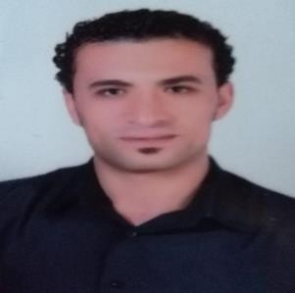

OBJECTIVE:
To obtain a full time position as security this offers a professional working environment and enables me as Security Guard.

PERSONAL DETAILS:
Name: Mostafa
Email: mostafa-394733@2freemail.com
Gender: Male D.O.B: 1/1/8891
Nationality: Egyptian Marital Status: Single Length: 188 CM Weight: 81Kg
Power of concentration: 6/6 EDUCATION:
Trading Diploma

WORK EXPERIENCE:
- As security guard from March 2008 till May 2009.

in Egypt As security guard from June 2009 till

in Egypt As security guard from Jan. 2015 till Aug. 2017.

Job Responsibility as Security guard:
- Over 8 years of experience in security guard position.
- Protection of VIPs.
- Protection of important building.
- Experience in handling weapons.

Personal skills:
- Ability to multi-task while maintaining a positive attitude.
- Proving ability to listen and respond to demanding guest needs and problem solving.
- Full aware of safety and emergency procedure.
- Ability to work in difficult condition.
- Ability to communicate with other and provide assistance.
- Ability to co-operate with staff.

Languages:
- Arabic (Native)
- English (Excellent)

