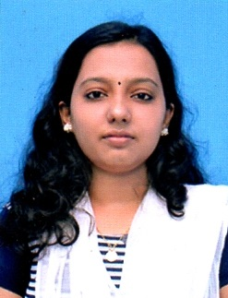
Athulya

Email : athulya-394750@2freemail.com

PROFILE SUMMARY

CAREER OBJECTIVE

To obtain a meaningful and a challenging position that would be helpful in development and willingness to utilize existing potentialities to the expectations of the company as well as gain, growth and achieve milestones.

PERSONAL STRENGHTH

- Good interpersonal skills
- Good analytical and problem solving skills
- Ready to accept challenges
- Vast knowledge of Accounting

EDUCATION

- B Com (Taxation) from University of Kerala.
- M Com from Madras University.

IT SKILLS

- Tally ACE, MS Office

CERTIFICATION

- ASAP from General Education and Higher Education Departments, Govt of Kerala.
- National Service Scheme (University of Kerala)
- Certificate in Housekeeping from Kerala Institute of Tourism & Travel Studies.

WORK EXPERIENCE

( Chartered Acoountant Firm) (One year experience)

Key Responsibilities:
- Goods & Services Tax (GST) Filing
- Finalisation & Filing of KVAT Returns
- Income Tax Returns Filing
- Prepare & maintain Statutory Books of Accounts
- Full- Cycle Accounting
- Financial Statement Preparation
- General Ledger entries & Audit
- Tax Audit of Individuals & Corporates
- Bank Reconciliation statement preparation
- Co-ordinating & Integrating activities

PERSONAL PORTFOLIO

Date of Birth : 25/07/1994
Gender : Female
Marital Status : Married
Nationality : Indian
Languages Known : English, Malayalam, & Hindi

PASSPORT DETAILS

Date of Issue : 07/11/2017
Date of Expiry : 06/11/2027

DECALRATION

I do hereby affirm that the information given above are true and correct to the best of my knowledge and belief.
ATHULYA

