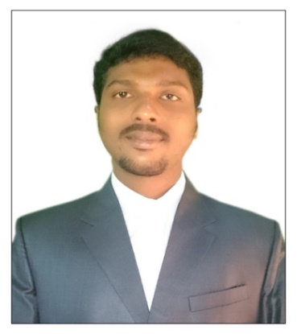

CURRICULUM VITAE
VIJAY
Mail Id: vijay-394767@2freemail.com

Career Objective:-
I would like to seek a position of competitive and challenging work, with best of my ability for the development of a progressive organization.
Experience : 5+ years
Current Designation : CIVIL ENGINEER
Key Elements:-
- Projects monitoring- Daily / Weekly /Monthly project report
- Taking care of quality of materials for concrete
- Completion of projects as per drawings from foundation to finishing.
- Co-ordinate with architect and structural consultant.
- Co-ordination / verification /construction material clearance from technical team
- Labor productivity report on monthly basis
- Material & Man power Schedule
- Preparation of Quantity taking off
Nature of duties:-
- Responsible for investigation and checking of the sites for the project.
- Handling the construction lay out and map designing
- Coordinating with the suppliers and dealers for the materials
- Check of the safety of workers and others at the site.
- To ensure the quality of the product used in the construction.
- Checking the all the technical equipment’s are in good working condition
- Checking that all the government policies and rules are being followed
- coordinating with the other staff as per requirement
- Maintaining the daily and monthly reports of working

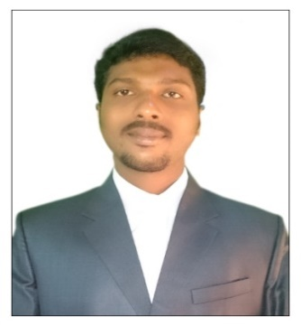

VIJAY
Mail Id: vijay-394767@2freemail.com

Work experience details: -

- Civil Site engineer - Dubai, U.A.E.
(2016-present)

- We are doing ministry of interior jobs. Present we are constructing new Army accommodation at Army Camp Al Ain.
- We have done civil works and ware house Maintenance works at al Ghurair foods and transport l.l.c jabelali Dubai.
- We have done Staircase emergency exist handrail works at HSBC Bank-Down Town Dubai

- Civil Site engineer -Dubai, UAE.
(2015-2016)
- We have done Interior Modification works and Maintenance works at RTA Main Head Courteous.

- Civil Site engineer - OMAN
(2013-2015)
- Inspects projects sites to monitor progress and ensure design specification as well as safety and sanitation standards are being met.
- Guide managerial and industrial personnel by providing technical advice regarding design construction, structural repairs and program modifications.
- We have done twin villa projects at Al Seeb and Amarat (Sultanate Of Oman)
Jobs Handled:
- Responsible for investigation and checking of the sites for projects
- Responsible for all necessary project construction materials, supplier and subcontractor that need to be submitted and approved by client.

ACADAMIC PROFILE:-

QUALIFICATION | UNIVERSITY/BOARD | YEAR OF PASSING
(B.E)CIVIL ENGINEERING | VINAYAKA MISSIONS UNIVERSITY(CHENNAI) | 2012
H.S.C | ADITYA JUNIOR COLLEGE,WEST .GDT,A.P | 2008
S.S.C | Z.P.H.SCHOOL | 2006

SKILLS DETAILS:-

- Skilled in MS office, MS excel, MS Power point.
- Basics of AUTO CAD.

VIJAY
Mail Id: vijay-394767@2freemail.com

PERSONAL PROILE:-

Date of birth | 30/04/1991
Gender | Male
Languages | Telugu , English ,Tamil, Hindi
Martial status | Single
Nationality | Indian

- DUBAI SOCIETY OF ENGINEER MEMBERSHIP CARD

- DUBAI MUNCIPALITY APPROVED STRUCTURAL STEEL ENG G+1 .
Qualified on :-(The construction of a ground metal constructions contracting + bungalows)

- UAE DRIVING LICENSE

Declaration:

I hereby declare that the above information is true to the best of my knowledge.

Vijay

