Email: moitheen-394770@2freemail.com

PROFILE
CAREER HIGHLIGHTS

Date of Birth : 06-10-1990 Marital Status : Married Gender : Male
Nationality : Indian
with KSA License
Visa Status : Visit Visa 90days
Management Professional Seeking a Full time position in the field of Management Administration, Sales and Business Development, Customer Service, , Marketing, Social Media Management where I can Apply my knowledge and Skill for the continues Improvement .Exceptionally well organized with a track record that demonstrates self-motivation, creativity and initiative to achieve both corporate goals. Work with positive attitude to contribute the healthy functioning of the organization .

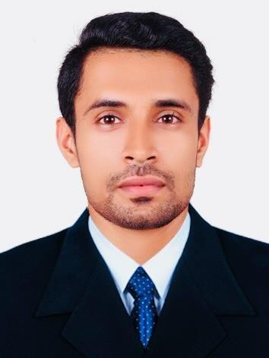
Movbbv
MOITHEEN

WORK EXPERIENCES

Operation Executive Trainee (Freight Forwarding)(11/2018 – 8/2019) (Jebel Ali Dubai,)
  - Handling export & import operation activities
  - Maintenance of Customs duty/documents
  - HandlingcustomsclearanceprocessandFreightforwardingofSea&air&Land
  - Managing customs bill of entry through E-Mirsal
  - Preparation of Job card in System, repacking,

Sales Development Manager (08/2015 –08/2016)
(Dammam, Saudi Arabia)

  - Develop clientele by researching and targeting relevant industry and market for new business.

  - Identify potential business deals by contacting potential partners; discovering and exploring opportunities.

  - Identify potential business opportunities B2B market by analyzing market strategies
  - Close new business deals by coordinating requirements

Admin Cum Logistics Coordinator (07/2014 -06/2015)

(Chennai, India)

  - Dispatch/routing, Quality assurance
  - Recruit and coordinate logistics staff (e.g. truck drivers) according to availabilities and requirements
  - Coordinating and monitoring supply chain operations
  - Plan and track the shipment of final products according to customer requirements
  - Utilizing logistics IT to optimize shipping and transport procedures
  - Preparation of Payroll Data in coordination with HR team
  - Preparation of Form16 for employees and Vendor and ensure timely distribution to relevant parties

EXPERTISE
EDUCATION

- Administration & Business Development
- Coordination ,Customer Service
- Office and Operation Management
- Marketing, Accounting , Key of Accounts
- Social media Management
- Insurance, Banking

2012 -2014

2009 -2012

Master of Business Administration (MBA) major in Finance & Marketing at East West College of Management, Bangalore (Bangalore University, Karnataka, India)

Percentage: 68%

Bachelor of Commerce (B.com) at Brilliance Academy (Calicut University, Kerala, India) Percentage: 60%

SKILLS
LANGUAGES

- Leadership and Coordination
LANGUAGE | READ | WRITE | SPEAK
English | Yes | Yes | Yes
Hindi | Yes | Yes | Yes
Malayalam | Yes | Yes | Yes
Tamil | Nil | Nil | Yes

- Communication and Sales
- Planning and Forecasting
- Public Speaking and Supervising
- Administration and Customer handling
- Marketing and Business Development
COMPUTER PROFICIENCY
CERTIFICATION

OPERATINGSYSTEMS : Windows ,Linux,Ubuntu
  - OFFICETOOLS : MS–Office
  - OFFICESOFTWARE : Libra office ,Mac office tools
Diploma in Indian and Foreign Accounting from GTEC Computer Education, Kerala, India (Affiliated by Ministry of Education Singapore)

♦

EXTRA CURRICULAR ACTIVITIES

  - College level Soccer Team Member
  - Participated in MSM (Muslim Student Moments) ,Kerala
,India
  - Participated in Calicut University Private College Level Soccer Tournaments
  - Winners in College Level Pencil Drawing Competition

DECLARATION: : I, Moitheen, hereby declare that the information contained herein is true and correct to the best of my knowledge and belief.

Moitheen

