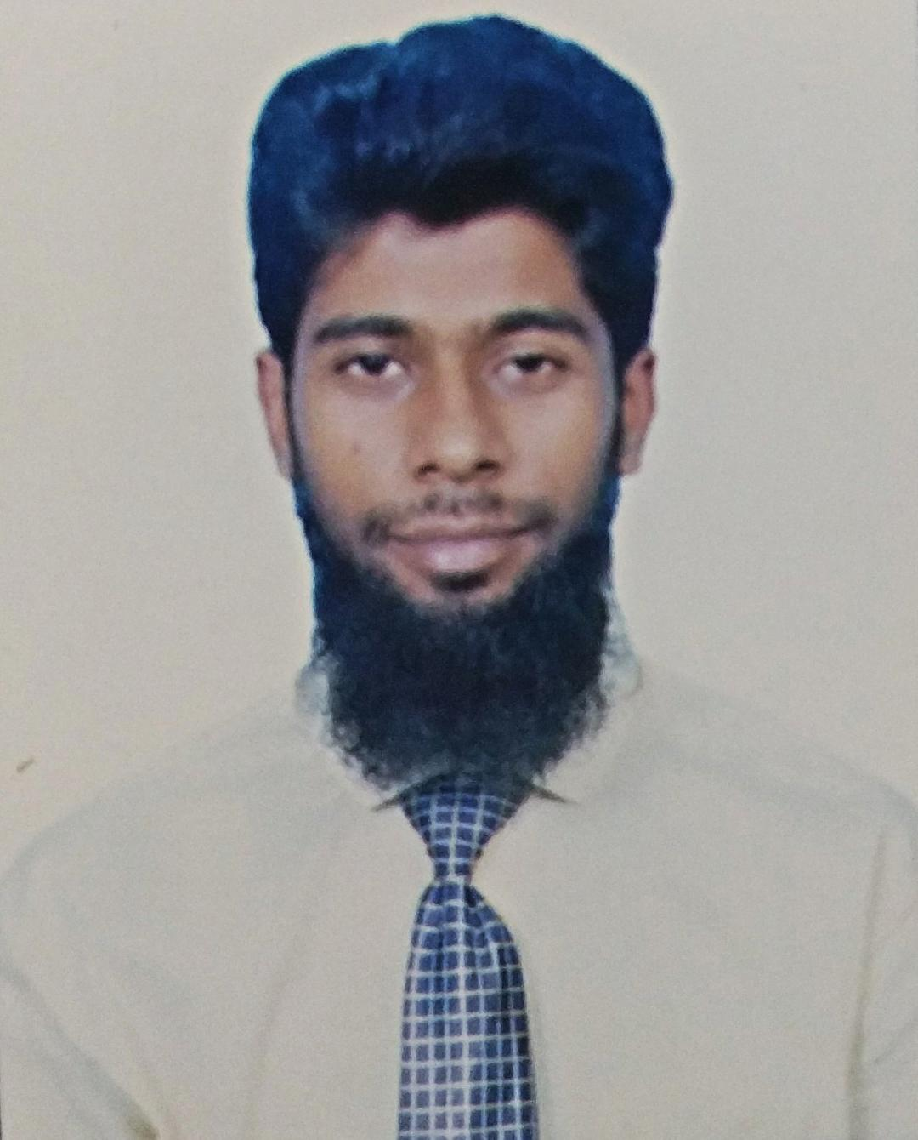
Mohd Fahad
E-Mail:-mohd-394795@2freemail.com

Professional Summary:
Highly efficient and diligent administrative office professional with seven years of experience in management. Capable leader with excellent skills in delegating responsibilities to others and supervising and evaluating for effective task completion. Enthusiasm for delivering excellent service to customers and other visitors in the office setting. Commitment to upholding company policies and procedures when working with staff members and motivating team. Strong organizational skills and excellent attention to detail when dealing with paperwork.

Core Qualifications:
- Talented in dealing with multiple assignments at once and an ability to meet deadlines and complete accurate work at all times.
- Highly capable oral and written communicator when discussing issues with staff members or delivering correspondence to individuals.
- Exceptional ability to deliver outstanding customer service and diffuse customer complaints or problems.

Experience:

Worked with India Sales & Marketing Pvt. Ltd as Sales Representative fromJul 18 to Sep 19 date.

- Actively seek out new sales opportunities through cold calling, networking and social media
- Excellent Sales service to Ensure high levels of Customer Satisfaction through.
- Inform Customers About Discounts and Special Offers.
- Stay up-to-date with new Product/Services
- “Go the extra mile” to drive sales.
- Manage Returns of Merchandise.
- Welcoming Customers to the store and answering their Queries.
- Gather feedback from customers or prospects and share with internal teams

Worked with Eureka Outsourcing Solutions as Customer Service Representative from Jan 17 to Jun 18.
- Contacting potential or existing customers to inform them about a product or service using scripts.
- Should have a Clear idea before making the conversation to a Person or any Organization.
- Answering Questions about Products or the Company.
- Should finish the conversation with a Thanking note for Sparing time.
- To gather maximum Information from the Person, prepare a list of Questions in Priority Order.
- Asking Questions to Understand Customer Requirements and close conversation.

Education:
- Secondary School,Jamia Urdu Aligarh, Uttar Pradesh, India.
- Senior Secondary School, Jamia Urdu Aligarh, Uttar Pradesh, India.

Personal Dossier:

- Date of Birth 3rd Jan 1995
- Passport No M0258039
- Marital StatusSingle

