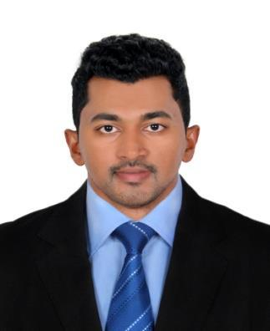
CURRICULAM VITAE

Sibin

Dubai
United Arab Emirates
Email:sibin-394797@2freemail.com

Career Objective

Intend to build a career with a leading business house with committed & dedicated people, which will help me to explore myself fully and realize my potential. Willing to work as a key player in a challenging & creative environment.

Skills

- Socially adept
- Good with numbers
- Able to provide quality leadership to sales people
- Strong communication and IT fluency
- Creative talents and the ability to solve tough problems
- In-depth knowledge of the industry and its current events
- The ability to handle pressure and meet deadlines
- Skill in prioritizing and triaging obligations
- Attention to detail
- Excellent time management and organization

Work Experience

Business Development Officer

Dubai, U.A.E | 2018 to 2019

- Design and implement a strategic business plan that expands company’s customer base and ensure its strong presence

- Managing and executing sales and promotions plans for customers.
- Making follow up calls to close the sales.

- Build and promote strong, long-lasting customer relationships by partnering with them and understanding their needs
- Dealing to customers from many nationalities such as Asian,European. And middle east
- Present sales, revenue and expenses reports and realistic forecasts to the management team

- Identify emerging markets and market shifts while being fully aware of new products and competition status

- Prepare list of all prospective customers for sales lead

Business Development Engineer
Kerala, India

- Making the contract with companies and industries.
- Negotiating contracts and packages

- Aiming to achieve monthly or annual targets.

Marketing and Sales Officer

Dubai, U.A.E | 2016 to 2018

- Responsible for achieving individual targets across all products (Personal loan,Auto loan,credit cards)

- Closed new business and developed negotiating strategies by coordinating prospects goals and requirements with company objectives and procedures.

- Developed, coordinated and implemented sales strategies that identified and produced new business in two different markets/ states.

- Guided and directed sales team professionals,analysis for management decisions and strategic planning.

- Attend industry functions, events, and conferences; providing feedback and information on current market/creative trends.

- Facilitating the entire sales process; cold calling, lead generation, closing sales

- Achieving targets by giving proper follow up by calls,meeting and email activities.

- Providing the guidance to team members as required on any questions related work assigned.
- Applied initiative to immediately act upon issues to achieve a resolution.

- Effectively communicated transport requirements to clients over the phone, in writing and in person as well as clarifying client freight requirements with operational staff.

2013 - 2015

- Closed new business and negotiating strategies by coordinating prospects goals and requirement

- Developed,coordinated and implemented sales strategies that identified and produced new business in two different markets/states

- Established CRM to increase sales,improve sales forecasting,and enhances account tracking on new and existing clients.

- Facilitating the entire sales process,cold calling,lead generation,closing sales

- Ability to chase up new business opportunities.

- Planning conducting team meetings on weekly & monthly basis,overseeing operational efficiency in workshop to improve profitability

- Maintaining relationships with key clients.

- Excellent lead generation and development skills.

- Contacting customers at regular intervals by telephone / personal meetings ,identifying areas and implementing measures to maximize customer satisfaction levels.

Education

B.Tech in Electronics & Communication | 2012
Mangalam college of engineering ,Kottayam -India
Higher Secondary
St Mary’s higher secondary school | 2008

Personal Information_

Date of Birth |  | : 07/01/1991
Marital status |  | : Married
Nationality |  | : Indian
Language Known |  | : English, Hindi, Malayalam, Tamil
Driving License |  | : LMV UAE
Visa Status |  | :Visiting Visa
Visa Validity |  | :
Declaration |  | _ | _

I do hereby declare that all the above information furnished by me are true and correct to the best of my knowledge.

Place: Dubai

Date:

Sibin

