CURRICULAM VITAE
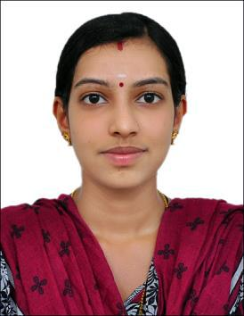

Geethu

Sharjah. UAE

E- mail: geethu-394806@gulfjobseeker.com

Objective

To work for a growing and challenging organization having an innovative environment that will best utilize my creativity and analytical skills and allow me to be part of a creative team. Dedicated self - motivated achiever who is committed to success and adapt at juggling multiple tasks in a high pressured environment.

Educational Credentials

- Certified Medical Coder – AAPC Member ID : (Cigma Medical coding Academy) 
 

  - BSc Nursing (60% in 2013) (Dr. NTR Univercity Andrapredesh, India) 
  
-  HSE (64% in 2008) – Kerala Education Board 

 

Professional Experience

Worked as staff nurse in Apex coronary care unit for 2 years.

1 Year experience- in a Speciality Hospital ,Saket , New delhi

1 Year experience – in Lajpatnagar,New delhi

Computer Proficiency

Application MS Office (Word, Excel)

Languages Known

English, Hindi, Malayalam

Strength

- Extensive knowledge of medical terminology, anatomy & Physiology.

- Enthusiastic, Energetic and self-motivated

- Good knowledge of clinical practices and protocols.

- Work well under pressure

- Hard working and result oriented

Personal details

Nationality

Indian

DOB

02 nd

July 1991

Visa status

Husband Visa

Sex

Female

Marital Status

Married

I hereby declare that the information furnished above is true to the best of my knowledge and belief.

Geethu

