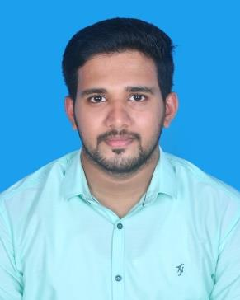
STEFIN

Stefin-394812@2freemail.com

Visa status: Visiting Visa

OBJECTIVE

To Work for an organization which will help in value addition and serve as a spring board to move ahead in my career by providing me interesting career opportunities and harness the best of my caliber.

ACADEMIC PROFILE

- Diploma in Electrical & Electronics Kerala State Technical Board- University, India with an aggregate of 85 % [2011-2014].

- Plus 2- Board of Higher Secondary Examination, Kerala with an aggregate of 76% [2009-2011].

- S.S.L.C with an aggregate of 89% from Board of Public Examination, Kerala [2009].

OTHER QUALIFICATION
- NEBOSH International General Certificate in Occupational Health and Safety.

- IOSH Managing Safely.

- HABC Level 2 International Award in Risk Assessment.

- Medic First Aid.

PROFESSIONAL WORK EXPERIENCE

- Worked as QUALITY CONTROL SUPERVISIOR in Sharjah from 15th October 2016 to 11th October-2018

- Worked as QUALITY INSPECTOR in Sharjah from 15th October-2014 to 15th October-2016.

JOB RESPOSIBILITIES –

QUALITY CONTROL SUPERVISOR- Reporting To Quality Manager

- Examine the quality of raw materials, its dimensions, strength, texture and composition with assessment tools.

- Carrying out studies for the products those haven’t attain the quality, identifying problem and developing corrective and preventive action for avoiding further errors.

- Preparing daily analysis report and submit to quality manager.

- Preparing monthly evaluation report of the quality of products.

- Coordinate with purchase department and identifying the good quality raw materials in the market.

- Communicating with suppliers, if any issues.

- Thoroughly analyzing the product and make sure the quality of products is attaining the clients demand.

- Regular training and education to be given to the workers.

- Provide required personal protective equipment from safety department.

QUALITY INSPECTOR - Reporting to Quality Control Incharge

- Approves incoming materials by confirming specifications; conducting visual and measurement tests.

- Approve or reject raw materials with respect to quality standards and record supplier performances.

- Approves finished products by confirming specifications.

- Monitor operations to ensure that they meet production standards.

- Preparing daily analysis report and submit to quality Inspector.

- Accept or reject finished items. Communicating with suppliers, if any issues.

- Remove all products and materials that fail to meet specifications.

- Discuss inspection results with those responsible for products.

- Inspect procedures of the entire production cycle to ensure they are efficient and comply with safety standards.

SKILLS
Technical Skills:
- MS Office
- E-cad
- Operating systems- Windows & Linux

PERSONAL INFORMATION

Date of Birth | : 11-09-1993
Sex | : Male
Age | : 26
Marital Status | : Single
Nationality | : Indian
Languages Known | : English, Malayalam, Hindi and Tamil
Hobbies | : Playing Cricket, listening music, Driving.

DECLERATION

I hereby declare that the above written particulars are true to the best of my knowledge and belief.

Date : STEFIN

