CURRICULUMVITAE
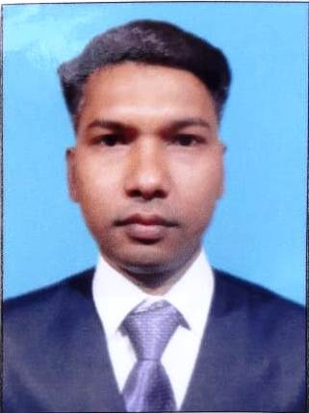
AJAY
D.O.B : 15-03-1986
Nationality : India
E-mail: ajay-394829@2freemail.com

OBJECTIVE:
I want to improve my knowledge and build new kills by working in a organization and seeking a position as a Accountant at any organization where I can proper utilized my talent, and I am keen to find a new, suitable challenging role within any organization. And my personal dream is to work in UAE, I know in UAE work is not easy and I love to take that opportunity and I just on daily basis work with my dream to complete it by knowledge and my skills .
WORK EXPERIENCE:
Over 12 + years experience in Sr. Accountant in a Manufacturing Company of Hume Pipe, Tiles, Paver & Block and Electricity Pole and Micro Silica Trading etc. at JALPAIGURI – W.B., 2 years experience in Accountant at Surat (Gujrat), and 2 years experience in Junior Accountant at Siliguri (W.B.), and 1 years experience in Account Asst. & Store Keeper at Birpara, Jalpaiguri (W.B.).

ACCOUNTANT CUM MANEGER:-
( DUBAI)

Maintain day to day transaction, Sales & Purchase A/c, Cash Book & Bank Book maintain etc. (Dubai).
Duties & Responsibilities
- Internal Audit, GST return, Sales Tax Return (VAT & CST) or Excise Return Preparation, Manufacturing & Cost Accounting and Balance Sheet preparation etc.

Relevant Skills:
Microsoft Office, Tally ERP.9, Compact, Ace, Fact & Internet.
Preparing GST / Sales Tax / Income Tax / TDS Return and filling.
EDUCATIONAL BACKGROUND:
B.Com (Bachelor of Commerce) from North Bengal University (N.B.U),
At Siliguri ( W.B). in the year of 2009Incomplete.
Completed 12th (Higher Secondary) in the year of 2006.
Completed 10th (Secondary) in the year of 2004.
Computer Skills:-
CFA (Computer Financial Accountant) from Brainware Computer Academy in Siliguri (W.B.) Year of Complete: 2008.
MS Office + Tally from ZedCA (Zed Career Academy) in Alipurduar (W.B.) Year of Complete : 2007,
Basic of IT ,(MS – Windows, MS Word, MS Excel, & Tally 6.3 Internet enabled) , MICE(Manipal Institute of Computer Education) from Birpara, Jalpaiguri (W.B.) Year of Complete : 2006.
Knowledge on Basic Computer Hardware.
Languages:
- English : Fluent in speaking and writing
- Hindi : Fluent in speaking and writing
- Bengali : Fluent in speaking and writing
- Nepali : Fluent in speaking
PERSONAL INFORMATION:

DOB : 15th March, 1986
Blood Group : B+ve

