JELESH
Email: jelesh-394830@2freemail.com

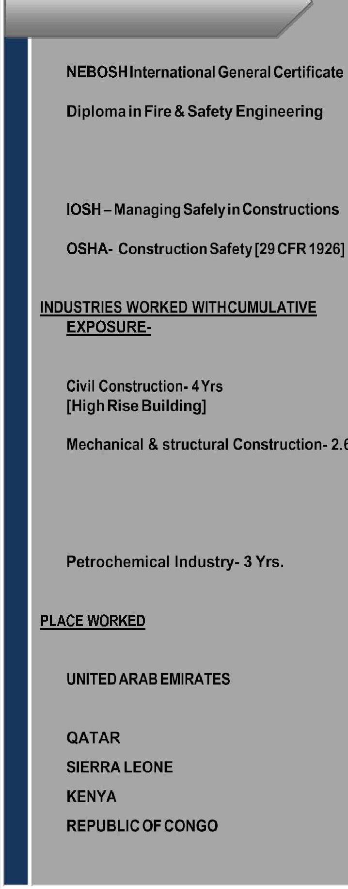
LEAD

➢ 

➢ 

- Lead Auditor –

OHSAS 18001:2007 [IRCA]

➢ 

➢ 

➢

➢ 

Yrs.
- Tunnel work industry– 2.2 Yrs.

- Mining Industry- 1 .10 Yrs.

➢ 

➢ 
- INDIA

➢ 

➢ 

➢ 

➢ 

PURPOSE STATEMENT

- HSE professional having 14 Yrs. Experience with Civil construction, Mechanical, Structural,Tunnel, Mining andPetrochemical etc. Highly pro-Active and articulating in

Communication and processing, excellent leadership, management and persuasive skills bring about changes in the work culture particularly on Health, Safety and Environmental issues.

SYNOPSIS

  - An incisive professional with around 14 years of cross-functional experience in handling Health, Safety Operations at projects

- Environmental impacts control measures. Adroit at:

  - Handled key projects with the distinction of managing HS&E Aspects at projects of diversified nature across the career span.

  - Well proficient with present construction methodologies, systems in compliance with international standards.

  - Exemplary relationship management, communication skills with the ability to Network with project members, consultants, contractors, and statutory agencies with consummate ease.

  - Compliance with international standards such as OHSAS 18001- 2007 & ISO 14001.

  - Occupational health related assessments and compliance procedures.

ORGANIZATIONAL DETAILS

From

19-06-2018 – Till date in Abu Dhabi, UAE as an HSE ENGINEER.
Project:
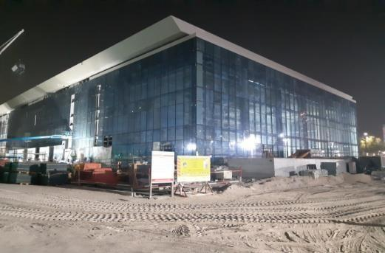
♦ | Adnoc Business Centre
 | Client: Abu Dhabi National Oil Company.
 | Consultant: Hill International, UAE

ADNOC APPROVED

Current Accountabilities:

- Manage overall implementation of the client approved project-specific Safety & Loss Prevention program with company field work force and subcontractors. Report administratively to the project manager and functionally to the corporate HSE Manager.

Represent Company in all matters pertaining to health, safety, security and environmental issues with the client and perform related coordination activities.

- To assist in the development and implementation of company’s HSE policy, standards & procedure, which incorporate UAE statutory requirements and guidelines along with the international practice

- To assist in the implementation of HSE Management system at the project level coordination with the line management.

- Review the HSE Management system periodically at project level; establishment and implement new procedure in coordination with main offices, relevant to the progressing work activities when ever deemed necessary during the execution phase of the project.

- Exemplary relationship management, communication skills with the ability to network with project members, consultants, contractors, and statutory agencies with consummate ease.

- To provide any professional advice to the project team members on HSE issues.

To monitor the established plans to achieve HSE goals & objectives of the company for the projects to provide data & feedbacks timely to main offices for efficient tracking.

ORGANIZATIONAL DETAILS

From

05-04-2016 – Feb 2018 Redis in South Africa, as an HSE ENGINEER.

Project:

- Base Titanium Project Ltd Client: Base Resources Ltd, Australia Consultant: Ausenco, Australia

Duties and Responsibilities

- To assist in the development, implementation and monitoring of emergency response procedure sand to review at periodically in order to reduce the risk to personnel, assets, environment and company reputation.

- To conduct emergency response drills to verify the effectiveness of standing procedures.

- Provide appropriate HSE training and assist with the development of an HSE competency assurance process within the organization.

- To analyze and evaluate company HSE performance through accurate & timely reporting against scheduled plans / targets, including preparation of accurate statistical data pertaining to the project for onwards submission to client and corporate offices.

- Conduct accidents and incidents investigation right after the notification and preparing recommendations and control measures to prevent recurrence.

- Ensure onboard security, fire, first-aid and welfare facilities and procedure appropriates to the works are provided and proper maintained.

- To support with action to ensure that the subcontractors manage in accordance with the Company and Client HSE policies and procedures.

Feedback

Earned appreciation as good team player with success-oriented work nature & dedication.

ORAGANIZATIONAL D E T A I L S

From

12-11-2013 – Jan 2016 in Doha As an HSE supervisor.
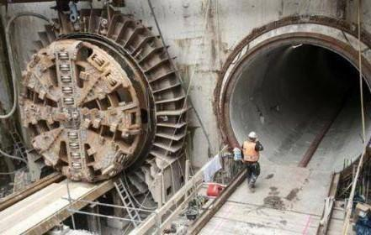

Project:
♦ Lusail Development Sewerage Treatment

Client: Qatari Diar/ Lusail

Consultant: Qatar Building Company

Duties and Responsibilities

- Preparing Risk assessment, work permit and total safety task instruction as per the job requirement.

Coordinating with weekly and monthly Safety and Environmental meeting.

Conducting safety induction to new employees for enhancing their safety orientation and maintaining their records for future reference.

- Monitoring and preventing potential work place safety hazards through routine inspection and training.

- Maintaining accurate and up to date documentation of policies, procedures and data.

- To access the current status of the issues.

- To develop and initiate safety promotion scheme for positive reinforcement of safe behaviors and employees.
- Work place inspection periodically.

ORGANIZATIONAL DETAILS

From
01-05-2007- May 2013 in Delhi, as an HSE ENGINEER

Project:

♦

Addax Bio-Energy

Client: Addax, Belgium

Consultant: De Smet, UK.

Roles and Responsibilities

Conducting safety induction to new employees for enhancing their safety orientation and maintaining their records for future references.

- Ensuringpermittoworksystemthatarecompiledbeforeanycriticalactivitiestoavoidany unacceptable accidents / incidents.

- Conducting fire and safety inspection including firefighting equipment.

- Identifying needed personal protective equipment for the specific job and preparing requisition form for the approval manager.

- Identifying standard, requirements and implement best safety practices in onboard states public health.

Ensuring and implementing the color-code system for all lifting tools, tackles and power tools.

- Ensuring implementation of Lock out Tag Out system as required.

- To develop and initiate safety promotion scheme for positive reinforcement of safe behaviors and employees.

ORGANIZATIONAL DETAILS

From
20-09-2005 - Feb 2007
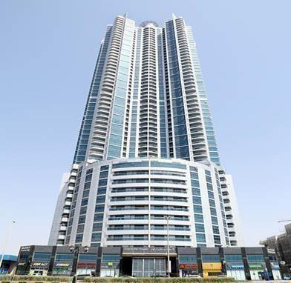
Dubai, UAE as a Safety Officer

Project:

♦

Rumillah Tower

Client- Cummings

Scope: High-rise Building Constructions.

Consultant: Adnan Saffarini

Duties & Responsibilities
- Full and maintain the lifesaving equipment and PPE.

- Conduct in refresher training for staff and work force.

- Conduct emergency drills in site and participate site emergency programs.

- Monitoring all aspects of Health, Safety and the Environmental and the promotion of good work practices

- Conduct Toolbox meeting as per the organization procedure.

- All accident and incident report to senior management and maintaining records.

- Permit to work system applied to all significant works.

- Frequently inspection for work site each day.

- Continue monitoring for all major concerned activity such as Tandem & Multiple Lifting, Confined space, Excavation, Piling works, Shaft work, Traffic management and Hot work

ACADEMIA

 | QUALIFICATION |  | NAME OF INSTITUTION |  | YEAR OF | STATUS
 |  |  |  |  | PASSING
 | Matriculation | S.K.V.H.S, Kuttemperoor P.o, Mannar |  |  | 1996 | Passed
 |  | [Boardof PublicExamination, Kerala]
 | Diploma in Mechanical | Ninans Poly Technic [Approved by |  |  | 2000 | Passed
 | Engineering | Govt.of India] Kottayam, Kerala, INDIA
 | B. Tech Mechanical | Dr. B. R. Ambedkar University, Agra, |  |  | 2001-2005 | Passed
 | Engineering | INDIA
PROFESSIONAL FORTE
 | QUALIFICATION |  | NAME OF INSTITUTION |  |  | YEAR
 | BSC – LEVEL 6 IDIP |  | Global Arabian Consultancy & Training L.L.C, Abu |  |  | 2019 SEP
 | [Pursuing] |  | Dhabi, UAE
 | NEBOSH - IGC |  | Ensign Safety Academy &Consultants Pvt. Ltd, |  |  | 2016
 |  |  | Cochin
 | IOSH |  | Ensign Safety Academy &Consultants Pvt. Ltd, |  |  | 2016
 |  |  | Cochin
 | OSHA |  | Centre for Professional Studies |  |  | 2009
 |  |  | [Affiliated by Indian Technical Education Council]
 | FIRE & SAFETY |  | Indian Technical Education Council, Kottayam, |  |  | 2001
 | ENGINEERING [ Diploma] |  | INDIA
 | HIRA |  | STED Council of INDIA |  |  | 2016
 | OHSAS 18001:2007 |  | TVE Certification Services Pvt Ltd |  |  | 2016
 | Lead Auditor
 | FIRST-AID Training |  | Basic Plus Certification |  |  | 2006
 | WORK AT HEIGHT |  | S.A.T.S Training Service, South Africa |  |  | 2013
 | Training
 | DCA[Diploma in Computer |  | CyberSpace Computer Education, Mannar,INDIA |  |  | 2007
 | Application]
 | OSHAD- [ Pursuing] |  | Al Jazeera Institute- Abu Dhabi |  |  | 2019 AUG
 | ID- 23769

KEY SKILLS
- Sense of Responsibility

- Excellent Co-ordination and Communication

- Initiative to Problem Solving

- Well-Motivated & Leadership

- Quick Grasping and Learning Ability Skills

PERSONAL DOSSIER
♦ | Date of Birth | : May – 02ND , 1982
♦ | Nationality | : Indian
♦
 | Passport | : Indian Passport
 |  | : Valid from 25-06-2010 till 24-06-2020
♦ | Driving License | : Indian Driving License- LMV & Motor Cycle with Gear
♦ | Driving License | : United Arab Emirates- LMV with Automatic

- Languages Known : English, Hindi, Malayalam

- Languages writeable: English, Hindi, Malayalam

♦ Marital Status : Married

DECLARATION

This is to certify that the above furnished details are true and correct to the best of my knowledge and belief.

JELESH

HSE Professional

Abudabi, UAE.

