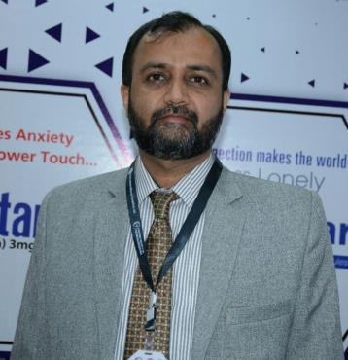
RESUME

HAIDER

Professional Data

Current Position:

Currently I am working as Senior Product Manager, looking after the pain management portfolio of Martin Dow in which main products are Musidin (Tizanidine),Proxen (Naproxen) & Prelin (Pregabalin). Musidin has got best growth by 22% and two of 3 SKUs have grown by more than 30%. Incremental business of Musidin is 19 Million during my tenure.

I am also working on an international clinical trial of Tizanidine in collaboration with our medical & compliance department for which I have done GCP certification as well.

Previous Position:

I worked as Product Manager & then promoted to Senior Product Manager in Pakistan which was run by Helium Pvt Ltd (May 2010-Aug 2014). Looked after the brands Citralka, Basoquin, Fasigyn, Combantrin, Entox-P & Zetamax. I was also responsible for giving training to all field force of our Business Unit.

Also worked for pilot project of Pfizer consumer division, launched Fibre7 & Alpha Balm in FSD & HYD successfully.

Achievements:

After analyzing market I designed campaigns on Citralka, Basoquin, Chloromycetin & Fasigyn, executed them successfully and got handsome growth in these brands like Citralka became 190M brand from 144M, Basoquin became 104M from 81M, Chloromycetin became 97M from 82M. Fasigyn growth rate also became 27.25% from 6.72%

Previous Experience:

- Worked as a “Product Manager” (March 2007-Apr-2010) looked after the products Azithromycin, Naproxen, Eperisone HCL, Ofloxacin & Ketotifen. I was also responsible for giving initial Product & Medical training to new colleagues of my group on national basis.

- Worked as Asstt.Product Manager (11 Months)

- Worked as Professional Sales Officer (Jan 2000-Feb 2006)

Educational Data

- E.M.B.A. (Marketing) from Preston University Karachi.
- B.Sc. (Pre-Medical) from Govt. Gordon College – Rawalpindi
- F.Sc. (Pre-Medical) from F.G. College, H-9 - Islamabad

Additional Courses Attended:

- Basics in Product Management (by: Mr. Puri)
- Professional Communication Skills I & II
- Group Communication Skills
- Micro Marketing
- Ethical Business Environment
- IFPMA Codes training

- IMS Training
- Good Clinical Practice (GCP Certification)

Personal Data

Date of Birth: 24th October 1977
Marital Status: Married

Nationality: Pakistani

References will be provided on requirement.

