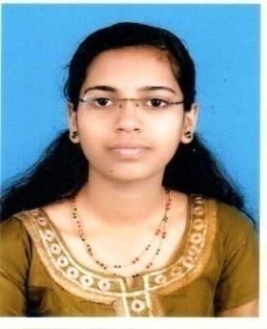

AKHILA

Dubai,UAE

Akhila-394859@2freemail.com

CAREER OBJECTIVE

Sharp driven Finance Executive with more than 1.4 years of proven experience in international finance and business operations. Enthusiastic in approaching organization wide challenges and excellent cross-functional management skills including working across multiple departments

EXPERIENCE

INDIA Sept 2018 –Till date

FINANCE EXECUTIVE

- Cash Application.

- Functioning in Account Receivables.

- Delivery of output on a 24 hrs SLA.

- Preparation of Vouchers and documents for application of cash on a daily basis.

- Work with clients in North America for timely allocation of funds received.

- Preparation of Summary Reports on a daily basis

- Management of Discrepancies and Reconciliations

ACADEMIC QUALIFICATIONS

Qualification | Board (University) | Institution | Year of | Score
 |  |  | Passing
MBA ( Finance.) | MG University | DC School of | June | 75%
 | (Kottayam) | Management and | 2018
 |  | Technology
B.com (Finance) | MG University | MG University | March | 60%
 | (Kottayam) | (Kottayam) | 2016
Plus Two | Higher Secondary | SJHSS | March | 89%
(Commerce) | Board Examination | Karimannoor | 2013
SSLC | Kerala State Board | SLT HSS | March | 80%
 | Examination | Vazhakulam | 2011

ADDITIONAL QUALIFICATION

- Pursuing Company Secretary ship (CS) Executive under ICSI

TECHNICAL SKILLS

- Microsoft Excel

- Microsoft Word

- Power Point

- Tally ERP 9

- NWPA Software

- Global Genius Software

PROJECTS

Technical analysis of top 5 Banks listed in NSE

CERTIFICATES

- Certificate Of Completion for Being An Effective Team Member

- Certificate for Completion of Communicating With Empathy

- Certificate for Completion of Developing Your Emotional Intelligence

- Certificate for Completion of Excel For Corporate Finance Professionals

PERSONAL STRENGTHS

•

•

•

•

•

•

Ethical Approach

Quick learner

Strong communication skills

Superior attention to detail

Decision making

Time Management

PERSONAL PROFILE

Date of Birth : 1st Nov 1995

Marital Status : Single

Nationality : Indian

Known Languages : English, Hindi, Malayalam

Hobby : Driving, Cooking

DECLARATION

I here by declare that all the above mentioned information’s are true to the best of knowledge. I submit my resume for your kind observation and favorable order.

AKHILA

