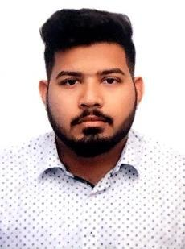
Sadiqullah

Mechanical Engineer

Sadiqullah-394862@2freemail.com

OBJECTIVE:

To understand the mechanics of engineering to the fullest. To give my level best in any organization for achieving difficult targets.

FINAL YEAR PROJECT:

Abstract: It’s a mini hydroelectric power system which produces power up to 15-100KW, depending upon the flow of water. It’s easy to install and has a low maintenance cost. The water passes through a straight inlet and then passes tangentially into a round-basin. There is a big vortex formation over the center bottom drain of the basin. Rotational energy is withdrawn from the vortex by the turbine, which converts mechanical energy into electrical energy by a generator.

INTERNSHIP EXPERIENCE:

- Toyota Indus Motor Company-engineering intern

- Sui Southern Gas Company ltd. –engineering intern

WORK EXPERIENCE:

- Worked as a Project Engineer, know how to lead during project and coordinate with subcontractors.

- HVAC Design engineering (Certification in process)

TERM PROJECTS:

- Design, Fabrication and Dynamic Study of a model Hydraulic Arm in 2nd semester.

- Build a mechanical 3-D printer (fixed Gantry) in fifth semester.

- Built an ultra-sonic sensing device in fourth semester.

ACHIEVEMENTS

SCHOLASTIC

- While in Internship in SSGC I learnt about design and maintenance of pipelines.

- While in Internship in Toyota I learned a lot about safety health and environment.

- Participated in First Entrepreneur leadership conference.

- Participated in DSU MUN (Model United Nations)
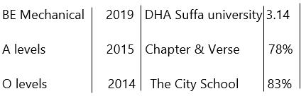

*CGPA of complete graduation
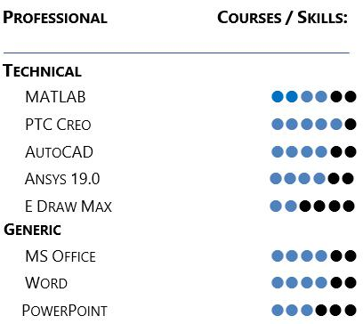

Personal Background

Date of Birth: June 13, 1997

Citizenship: Pakistani

Language: Hindi,Urdu,English

