Hassan  email: Hassan-394877@2freemail.com | 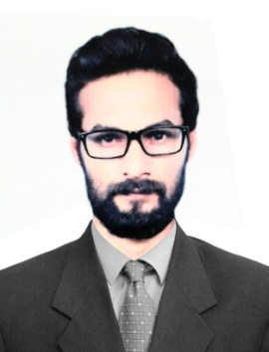
OBJECTIVE
Seeking a positionwith a company that will allow me to fully utilize my communication, organizational, and problem solving skills
ACADEMIC QUALIFICATION
- I.COM 2012
- FSC 2010
- Computer Diploma’s
- Matriculation 2009

PROFESSIONAL EXPERIENCE

CAREERS: (2019 Current Job, work as a salesman & delivery boy)
- Good behavior with customers.
- Good knowledge of all UAE ROUTS.
- Interpreted maps and followed written and verbal directions.
- Verified each delivery against shipping instruction before delivering to customer

TAXI DRIVER EXPERIENCE ( 2017-2018 )

- Well knowledge of all routs of UAE.
- Good behaviour with customer
- Pick and drop on time
- Always following the rules of RTA
- Confident in every situation

(2015- 2017) Work As Merchandiser.

- Merchandizing in iffco handlingMT customers including Carrefour, Lulu, Sarah Coop, and Union Coop &
- Coordinating with warehouses and sales team for delivering orders on time.
- Dealing with customers for provides well service.
- Inventory Planer, dealing in ICE creambrands, London Dairy and IGLOO and Tiffany Chocolate.

INVERTRORY CONTROLLER (2013-2015).

- Working in Oracle Software
- RAW Material handling
- Data administrator
- Handling physical &non physical stocks

CAREERS (Pakistan): (2010-2013) Worked as Sales man.
- Daily marketing different area’s
- Understand the impact of attitude customers
- Use the most appropriate way to communicate with different behavior types to the customers.
- Apply appropriate actions to effectively customer requirements.
- Meets commitments to customers

Business Owner: (2010-2011)

- Having setup and started my own business in Sport Merchandise
- Worked closely with suppliers to provide the best merchandise
- Effectively deal with customer, suppliers and government authorities to setup shop.
- Single handedly managed the business effectively to be able to start up a new venture

SKILLS

- Being calm and goal oriented in pressured situations
- Analytical, Planning and Organizational Skills
- Ability to handle surprises at any turn, persuasiveness and willingness to learn add to a competitive edge
- Dedication and drive as a hard-working individual with great emphasis on values and ethic.
- Attention to details
- Ability to really listen to customers

PERSONAL DETAILS

Date of Birth : October 11, 1991
Marital Status : Single
Languages known : English, Punjabi, Arabic, Urdu.
Driving License : Dubai, UAE
Nationality : Pakistani

