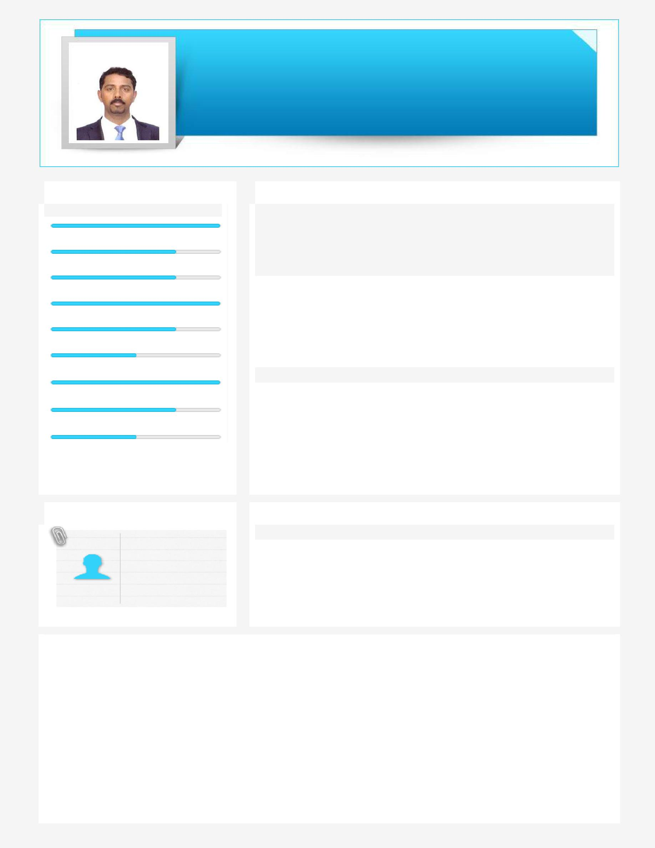
JUSTIN

Middle to Senior Level Assignments of Human Resource & Admin Professional

Industry Preference: If any
Visa Status: Visit visa, valid till 05th January 2020
Current Location: Sharjah-UAE
justin-394887@2freemail.com

Key Skills
Manpower Forecasting& Budgeting

Recruitment

Contract Labour Management

Compensation & Benefit

Time Keeping& Payroll Supports General Administration PRO Supports

KPI Management

Team Building & Leadership

Profile Summary

Result-oriented Professional with over 10 years of experience in manpower forecasting & budgeting, recruitment, compensation & benefit, labor management, timekeeping & payroll, general administration, PRO support works, KPI management, team building & leadership with oil and gas/shipbuilding /ship repair sector companies in the United Arab Emirates

Certification
One Year Diploma Oil & Gas course in Structural & Pipe Fabrication, 10th

August 2004 to 22nd August 2005 @from Balanagar Technical Institute, Kerala, India

Education

- MBA (Human Resource Management)-25thMay 2013 to 01st May 2016 @ from Alagappa University Karaikudi, Tamil Nadu, India

- BA. English Literature-25th May 2001 to 17thApril 2004@ from St. Jude’s College, Thoothoor, Tamil Nadu, India

Technical Skills

- Oracle Jde Edwards Enterprise One, Microsoft Office and Outlook
- Auto Cad

Soft Skills

Team Player

Communicator

Problem Solving

Planner
Collaborative

Decision Making

Work Experience

- Engineering company in Abu Dhabi (UAE) in Oil & Gas sector, designated as HR & Admin Support Officer from 10th Sept’2016 to 15th
Nov’2018

- In Abu Dhabi (UAE) in Ship Building /Ship Repair sector, designated as – HR & Admin Assistant from 08th Sept’2008 to
09th Sept’2016

CORE COMPETENCIES
- Recruitment & Selection (Talent Acquisition)

  - Analysed departmental requisition and coordinated with appropriate sources of recruitment
  - Shortlisted and handled preliminary interviews

  - Issued offer letter, confirmation, fulfilled joining formalities, induction and finally their placement in their respective departments

- Training & Development

  - Induction Training for newcomers
  - Carried out pre & post joining formalities

  - Organized site and departmental visits for newcomers
  - Identifying training needs for management staff & coordinates all training activities

  - Evaluates the effectiveness of the training programs conducted

- Performance Management

  - Facilitated KPI based Performance management system
  - Coordinated with various dept for timely assessment, confirmation & increment of eligible employees

  - Initiated and coordinated the performance review system, assisted respective dept. heads in conducting the appraisal process

  - Ensured structured feedback, managing the career growth initiatives and programs in various departments ensuring post appraisal follow-ups- Increments/ Promotions/counselling

- Manpower Forecasting

  - Expertise in directing production & planning team and attend the manpower requirement meeting and arrange the manpower on-time and without exceeding the contractual project cost

  - Having a well-connected professional network with more than 50 LS companies in the UAE
  - Manpower supply invoices checking and finalize to account team to release the payment on time

  - Identifying right service providers, negotiating the hourly rates, compiling agreement, ensuring discipline, license and reviewing contract labour requirement every week

- Employee Relation

  - Act as the initial point of contact for employees for their issues and queries
  - Motivate the employees and boost the knowledge of Labour law, company policies, and procedures

  - Assist the management to settle disputes between the employees
  - Coordinates all training activities and training records updated

  - Liasioning and coordinating with banks and employees for the furnishing of relevant information for the opening of bank accounts of the employees for direct crediting of their salary

- Timekeeping & Payroll Process Supports

  - Prepare , maintain and monitor accurate attendance records of staffs and employees with Oracle

  - Enter & approve the time sheets through Oracle and run the Cognos report and get the attendance sheet and update the leave entries, finally give the confirmation of payroll processing of monthly basis

  - Keep updated records for all time (OT) and attendance and personnel transactions such as a new hire, termination, leave of absence, benefits & deductions etc.

- Legal Activities & PRO Support Works

  - Exit and cancellation process of employees

  - Renewal of company camp facilities & updates the passport records in Excel sheet

  - Request to make the visas for new employees and renewing visas of existing employees and ensure all visa, medical and labor permits are up to date and arrange timely manner

  - Responding to staff queries on visa/labor/passport related matters and arrange the visa stamping on the passport, EID & medical arrangements etc…

  - New visa documentation & visa renewal preparations

- Leave Management

  - Systematic Oracle track record of staff & employees annual leave, sick leave, emergency leave, unpaid leave updates

  - Check the leave application form through Oracle and get approval from the management and making necessary arrangements: Ticket reservation, leave settlements, exit permit & conveyance

  - Hotel and ticket reservations for leave and leisure trips & prepare the PO through Oracle
  - Employee master creation through Oracle & run the Cognos report and get the payslips

  - Run the Cognos report and prepare the EOSB through Oracle

- Administration Management

  - Looked after overall office administration & Management i.e.
– Ensure the safety of the workplace& assign work of office boys, cleaners and securities

– Facilitate all the necessary materials for the newcomers ( seating arrangements , computer, Laptop, and other stationeries )
– Purchase office inventories ,arrange conveyance for staffs& reimbursement of bill claims
– Arranging wedding & birthday gifts, organizing pooja celebrations, games and eye tests
– Dealing with Petty Cash more than 15K

- Exit Interview

  - Assisted the head HR in the exit interview process

  - Exit formalities - Oversee the exit process for all employees including issuing all staff members with final settlement prepared and arranging for visa cancellation in coordination with the PRO

  - Assisted the department head to analyse various retention (on boarding) programs

TRAININGS ATTENDED
- Tool Box

- Stop Training Observation Programme (STOP)
- QHSE & HR Policies (IMS Awareness)
- HR 360 – Visa Process

Personal Details

Nationality: India /Marital Status: Married
Passport valid till 18th June 2026
Visa Details: Visit visa, valid till 05th January 2020
Driving License: Valid India License& UAE License in-progress

Languages Known: Tamil, English, Malayalam & Hindi

