AMAY
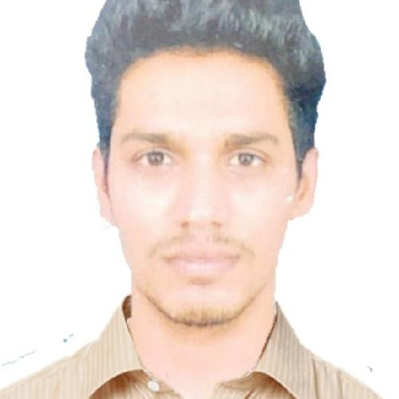

Amay-394892@2freemail.com

CAREER OBJECTIVE

-To secure the job in your organisation which could help me learn new skills and deliver my potential of financial analysis and strategic implementation of the new approach towards the development of the company.

-To associate myself with a company of repute where in my abilities and talents could be used to achieve the Organisation goals and to implement my skills.

-To be honest and successful in our duty with greater satisfaction.

EDUCATION

Goa University | 2019
MBA in Financial Services
7.64 CGPA (72.6%)
Vidya Prabodhini College of Commerce, Computer and Management | 2017
Bachelor of Commerce
Secured First class
Goa Board | 2014
H. S. S. C
Secured Pass class
Goa Board | 2010
S. S. C
Secured Second Class

WORK EXPERIENCE
2012 - 2017
Store Manager

Worked Part time as sales representative initially later promoted as store manager while pursuing my graduation degree. My role was to handle customers, sales, data entry, maintaining inventory, cash etc.

INTERNSHIP TRAINING

Summer Training (2018) from Sharekhan Stock Broking Ltd . under which develop a Summer training report.

Which was successfully submitted on time.

Corporate intership (2019) from Sharekhan Ltd. under which develop a project 'Emprical study on Macroeconomic factors affecting Stock Market performance' . Which was successfully submitted on time.

TECHNICAL SKILLS

Ms oﬃce Excel PowerPoint

LANGUAGE

English

Hindi

Marathi

OTHER SKILLS

Analytical ability

Communication skills

Problem solving skills

Decision maker

Quick Learner

Capacity for innovation

Team worker

INTERESTS

Sports

Traveling

Gaming

Volunteer work

Investing

Music

PERSONAL INFORMATION

Age- 25
Gender- Male
DOB- 20/05/1994
Nationality- Indian

Visa status- Visit

