Rehan
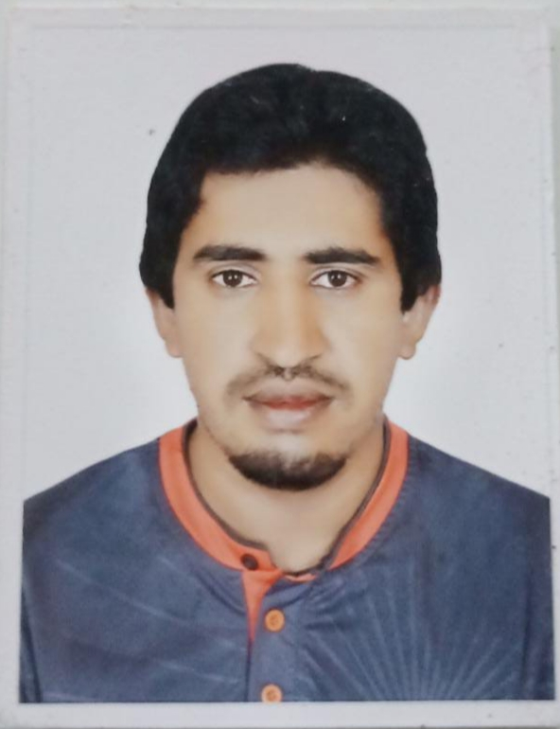
Driver (Light Vehical & Havey Tractor)
Dubai United Arab Emirates
Email: rehan-394905@2freemail.com

Career Objective:-
To contribute towards the growth and development of dynamic organization where there are ample opportunities to grow both professionally and personally and where I can utilize my skills and experience efficiently and effectively.
Personal And Academic Qualification:-
- Bachelor of Arts (B.A) Gomel University DI khan, Pakistan
- HSSC / Faculty of Arts (F.A) Govt Degree College #2 DI khan, Pakistan
- SSC (Matriculation) Govt high school Rattakulachi, Pakistan
Career Snapshot (04 Years):
- Organization in Ajman
- Position Held Driver
- Duration February 2015 to January 2019
Strengths:
- Well trained & experienced professional
- Expertise in administrative management
Driving License Detail:
- Issue Date February 2015
- License Type Manual #03& Heavy Tractor # 08

PERSONAL DETAIL
Date of birth : March 20,1991  Nationality : Pakistani  Marital Status : Married  Sex : Male  Religion : Islam  Language : English, Arabic | Visa status : visit Visa (01 months)  Reference will be furnished if required  Availability Immediately

