CURRICULUM VITAE
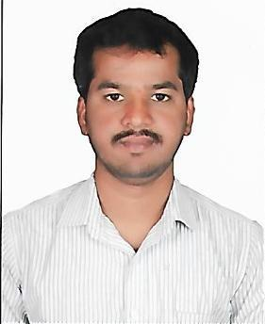

MURULI
QUANTITY SURVEY ENGINEER

Mail ID: muruli-394907@2freemail.com

EDUCATIONAL QUALIFICATIONS :

- Diploma in Civil Engineering from the V.I.S.S.J Polytechnic Bhadravthi Karnataka in the year 2009 with aggregate of 62.17% .

- BE in Civil Engineering from the ACSCE Bangalore, Karnataka in the year 2014 with aggregate of 61.00% .

TOTAL WORK EXPERIENCE – 6 YEARS

Scope of Work:

- Civil works & Structural works

- Interior Fit out Works

- Project Coordination

- Estimation & Billing , Monitoring Site Activity

- Façade & UPVC Work Billing

- PEB Stuctures

Computer Skills :

- MS – office
- Auto CAD

Page 1 of 4

PROFESSIONAL EXPERIENCE:

- Quantity Surveyor/Billing Engineer : From March 2018 to Till Date

Projects Handled: Basement , G+4 Commercial Building Responsibilities :

- From Structure to Finishing Detailed Estimation.

- Preparing & Raising RA Bills to Client.

- Vendor Bill Checking & Bill Certification.

- Taking Quote from Vendor & Negotiating.

- Material Reconciliation.

- Estimation Engineer : From 17th November 2016 to Sep 2017

Projects Handled: Industrial & Commercial Buildings, (Steel Structures ), PEB Structures

Responsibilities :

  - Estimation of Pre-Tendering and Post Tendering
  - Project Co-Ordination and Follow up of Work
  - Material management and Manpower Management,
  - Project Costing and Budgetting

- Billing Engineer : (FAÇADE DIVISION) From 15 September 2015 to 31 May 2016
Responsibilities :

- Study of Detailed Work Order and Working Dwgs

- Preparation & Submission of RA BILLS

- PRW Bill Checking

- Reconciliation

- Raising of Service Invoice and Commercial Invoice

- Preparation WIP Report.

Page 2 of 4

- Site Engineer : Bangalore From June 2014 to 13 September 2015

Projects Handled:

Residential Houses & Apartments of Double Basement, G+6 Responsibilities :

- Material and Man Power Management.

- Preparing & Raising RA Bills to Client.

- Vendor Bill Checking & Bill Certification.

- Taking Quote from Vendor & Negotiating.

- Material Reconciliation.

- Site Engineer – at Bangalore for KRIDL from May 2009 – July 2010

Projects Handled:

  - Auditorium For Scouts & Guides around 60,000 Sqft

  - Road Project at UG Road Diversion for Metro Project Reach2. RCC Drain. UG Sump. As per Highway Specification Around 2km.

Responsibilities :

- Material and Man Power Management.

- Preparing & Raising RA Bills to Client.

- Vendor Bill Checking & Bill Certification.

- Taking Quote from Vendor & Negotiating.

- Material Reconciliation.

Page 3 of 4

PERSONAL INFORMATION:

Date of Birth | : | 10th April 1989
Marital Status | : | Married

DECLARATION

I hereby declare that the above written particulars are true to the best of my knowledge and belief.

Place: Bangalore

Date: Muruli

Page 4 of 4

