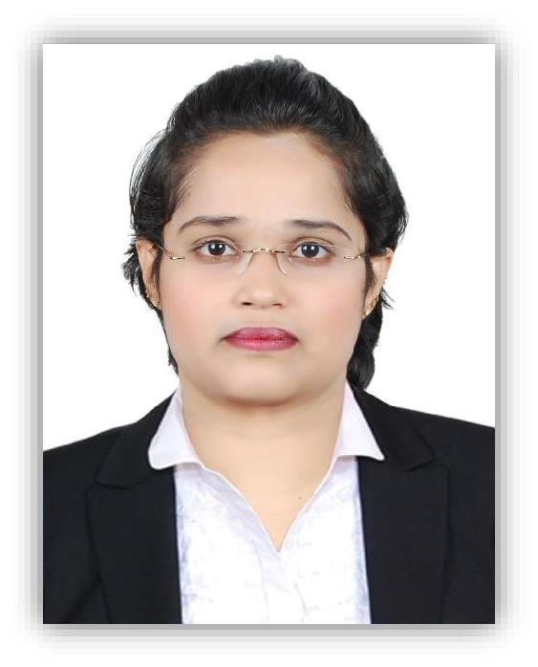
Ms. Raagasudhaa C V
B.E, PGDM,
PMP-PMBOK (Trained), ISTQB-CTFL

Raagasudhaa-394916@2freemail.com
Dubai, UAE

PERSONAL INFORMATION

DOB - 24/04/1994

Nationality - Indian Languages - English, Malayalam, Tamil, Kannada, Hindi, Telugu

Experience - 6 months in UAE & 4 years in India

PROFILE

6 months of UAE experience as:

Sales Representative - In the field of Banking, in credit card section, for Standard Charted Bank through TPA channel (B2C).

Product Management - Executive in the field of Employee Insurance by quoting the best available deals (B2B).

Having 4 years of specialization:

Lastly into Operations Management, mainly in the field of Incident Response, Traceability and Project delivery (Demo). Involved in Core Talent acquisition team for Technical selection and also into Project Management for traceability analysis & coordination.

Been into Software Testing for 3 years in Banking and Telecom Domain. Devising into Manual, Automation and Defect Management tools, by preparing FR, Test case Design, Scripting and Execution, & Defect logs for the complete release of the module, which includes User Acceptance Testing (UAT) and Regression Testing for both CBOL(Eclipse) & MBOL application, which includes UI, Functional and Backend processing and handled client interaction during Scrum calls for delivering of timely progress & clarifications

Practiced Agile methodologies & implemented Effort Estimation for effective utilization of resources during Proof of Concept (POC).

SPECIALISATIONS

-Business communication.

- Financial accounting.
.

- Principles of

Management

P a g e 1 | 3

SKILLS

Software Tester

Incident Response

Agile Methodologies

Defect Management

Documentation

Test Case Design

Basic knowledge of Database/ SQL

Core Banking Application

JIRA

HP – QC/ALM

HP - UFT

Macros

T24 Application

■■■■■

■■■■■

■■■■■

■■■■■

■■■■□

■■■■□

■■■■□

■■■■□

■■■■□

■■■□□

■■■□□

■■■□□

Operations Management Activities

Project Delivery

Incident Response

IT & Systems Management

Power Point Presentation

Documentation

■■■■■

■■■■■

■■■■■

■■■■■

■■■■■

WORK EXPERIENCE

Coimbatore ▪ Tamil Nadu ▪ India

Operations Management – Coordinator | 10/2017 – 01/2019

Involved in:

- Liaised to ensure smooth operations delivery.

- Coordinating and managing project tasks to reach traceability matrix.
- Ensuring compliance with company standards and procedures.

- Evaluated current operational performance and design plan for improvement.

- Providing guidance to achieve internal performance targets.

- Following standard operating procedures for efficient business operations.

- Maintaining up to date operations documents.

P a g e 2 | 3

India — Senior Software Test Engineer May 2016 - Oct 2017

Responsible for:

- Performing Integrated Project Delivery.
- Delivering each module through periodical updates
- Developing POC by managing 12 member technical team.
- Conducting cross module trainings.

- Coordinating with the DevOps team.
- Preparing presentation material for product display.
- Developing project goals through Traceability matrix.

India — Software Test Engineer May 2015 - May 2016

Experienced on:

- Responsible for design, scripting & execution of Framework.
- Working through Agile methodology.

- Retrieving the Host Data value at the Backend.
- Keeping track of Defect Management tools & Techniques.
- Presenting the Final Product for release.

- Accessing & Suggesting AML (Anti-Money Laundering) policies of Citibank, Bahrain, EMEA region.

PROJECT

Client Region Duration

: CITI Bank International – E2E Testing

: LATAM, NA, EMEA
: 3 years

Application : EBS Eclipse, HP-ALM, HP-UFT Module Name:

Fund Transfer, Cards, Digital Banking, UI verification, Field Level Data Validation and CI-EDW & ALS-EDW Tables execution using Big Data analysis.

CERTIFICATION

PMP® Certification | Based on PMBOK - 6th Edition ▪ Project Management Institute

Trained | 12/2018
ISTQB® Certified Tester Foundation Level | 7/2017

P a g e 3 | 3

