Abir
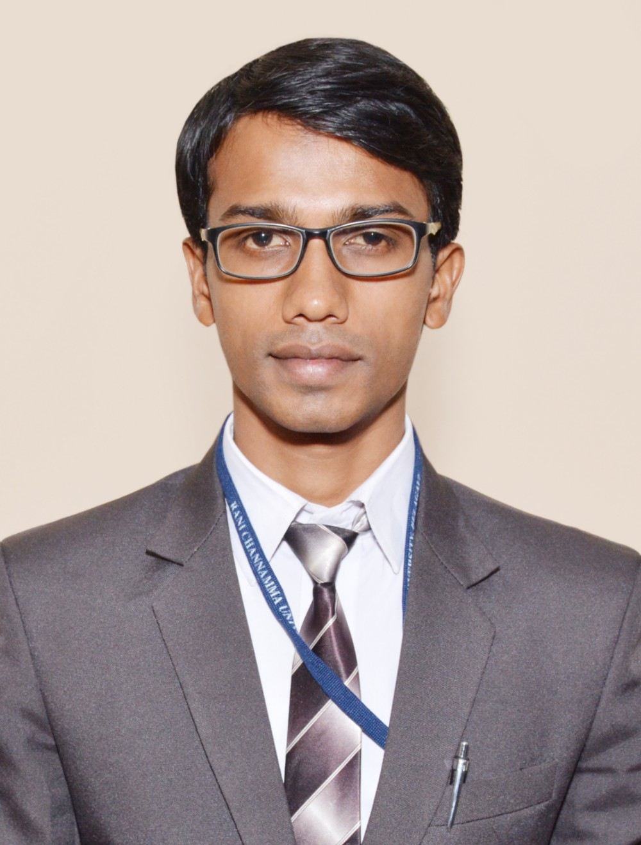
E-mail ID: abir-394922@2freemail.com

Career Objective:
To work with organization/company where i can contribute my theoretical knowledge and experience to achieve organizational objectives at the same time developing my career growth

Profile Summary:
- Good Communication and Managerial skills
- Quick learner, Hard Working and good in Time Management
- Believes in Smart Work and Result Oriented
- Can work under pressure
- Can work with a Team and can also be a Team Leader

Work Experience:
Worked as Officer HR & Admin for from July 2016 to August 2019
- Recruitment and Selection
- Checking employees’ attendance
- Preparation of Shift Roasters
- Granting leaves
- Finalization of Salaries
- Checking with employees’ uniform and other company disciplines’
- Looking after Training and Development activities
- Managing Transfers to other Locations
- Taking care of Performance Appraisal
- Looking after Transportation and Parking facilities
- Looking after Accommodation and Canteen facilities
- Cleaning and Water Management
- Event Management

Internship Projects:
- Internship Project of BBA for 30 days on “Sales Promotion Schemes” at Shantesha Motors Belgaum.
- Internship Project of MBA for 60 days on “Effectiveness of Advertising Strategies” at Shantesha Motors Belgaum

Education:
Year of Passing | Education | College | University | Aggregate marks
2016 | MBA  (Marketing & HR) | Rani Channamma University Belgaum | Rani Channamma University Belgaum | First Class
2014 | BBA  (General Management) | SGI’s Belgaum Institute of Management Studies, Belgaum | Rani Channamma University Belgaum | Distinction
2011 | PUC (Science) | Islamiya Composite PU College Belgaum | Bangalore Board | Second Class
2008 | SSLC | Islamiya School Belgaum | Bangalore Board | First Class

Extra-curricular activities and achievements:
- Won Marketing Guru Award in annual award ceremony of BIMS collage Belgaum.
- Won 1st prize in HR event in In-house fest of BIMS collage Belgaum.
- Organized, Managed and Won many other curricular activities.

Technical Skills:
- M S Windows, M S Office, Tally and Other Computer Applications
- Internet Applications

Personal Details:
Nationality: Indian
Date of Birth: July 09, 1992
Gender: Male
Marital Status: Married
Languages known: English, Hindi, Kannada and Marathi
Interests: Listening to Music, Reading Articles, Online Shopping

Declaration:
I hereby declare that the above written particulars are true to the best of my knowledge, experience and belief.

Place: Belgaum
Date: 11/10/19 Signature

