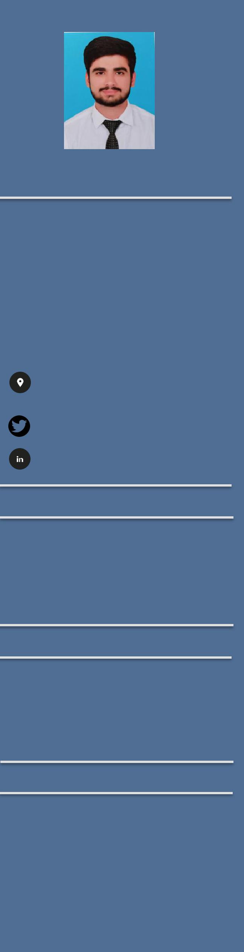

Zohaib

Mechanical Engineer

Pakistani

Male

Date of birth: 21st-Jan-1997

zohaib-394946@2freemail.com

Education

- University of Engineering and Technology (UET Lahore) 2015-2019

BS Mechanical Engineering CGPA 3.38/4.0

Hobbies

- Badminton

- Video Gaming

- Soccer

- Socializing

Computer Proficiency:

- ANSYS(Fluent)

- AutoCAD

- Solid work

- ABACUS

- MS Office

Summary:

To get a job that is both challenging and reward, where I can gain experience and use my skills to benefit the company

Experience:

- Internee (1month)

July 2017-Aug 2017

- Research Project in Millat Tractor Limited October 2018-May 2019

Projects:

- To make the model (dummy) of cellular production plant.

- To design a solar parabolic water heater with minimum cost requirements

- To design the depth guage for camhole of CD-70.

- To design the projectile launcher according to requirements

- To make a statement of work(SOW) of semester project

- Simulation of bridge on Solidwork and testing it on Abaqus software

- To design a chip conveyor for kira coolant tank.

- To verify research work of HVAC system functionality using ANSYS fluent.

- To design a piezoelectric generator using pizo sensor

Final year project:

To reduce the fuel consumption of MF 385 tractor engine (2wd, 4-stroke, 85hp, diesel) at Millat Tractor Limited

