 | C V
Name | Hany
Nationality | Egyptian
Religion | Muslim
Date of Birth | 22/04/1978
Marital Status | Married
Driving License | valid
EMAIL | Hany-394950@2freemail.com

QUALIFICATIONS :-

- Bachelor of Veterinary Medicine 2001 m (Good)

- Diploma graduate studies in the control of health on food in 2006 (good) and include: -

1. Health control of meat and dairy products
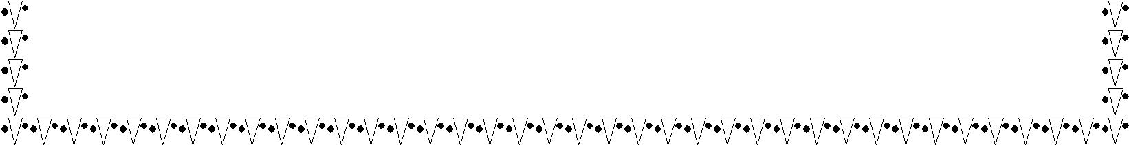

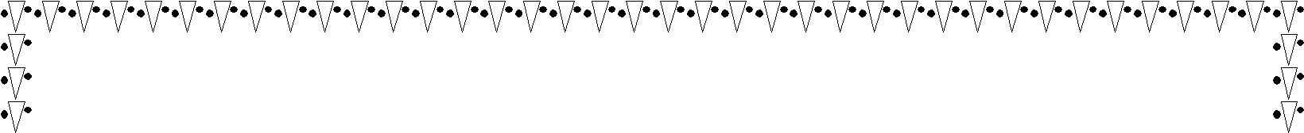
- Chemical analysis of food
- Food microbiology
4- Technology and food preservation

Scientific skills and interests: -

1. Health and food safety
2 - Application of health requirements and the HACCP system on food establishments
3 - Full knowledge of global quality systems ISO 22000 - GMP
Computer skills :-

I'm holds an ICDL certificate in computer leadership Excellent experience in working on various computer systems and dealing with the Internet

Languages: - Proficiency in English as a spoken and written second language

* Experience :-

16 years experience in quality control and food safety
- quality control manager

in the university cities (University of Beni Suef): - From 2017 to now
- Supervising the implementation of quality policy within the university cities

- Inspection of raw materials and ensure compliance with the required standards

- Develop plans to follow the critical control points of the HACCP system within the facility

- Control the safety and quality of food in the food circulation chain

- Develop plans to correct errors and try to find solutions

- Work on checking the final product and ensure its quality

- Reporting periodically

- Conduct training programs for workers to raise efficiency

- Sending suggestions for quality improvement

2 - Deputy project manager in the health control project in the municipality of Onaiza at the company ADECO for environmental consultants since in SAUDI ARABIA from 2015 to 2017
- Supervising the stages of project implementation in the field

- Training of health monitors on health control work and raising their efficiency for inspecting food facilities - Using inspection tools (inspector's bag) - Signing coordinates using GBS
- Establishment of a database of food facilities

- Preparation of periodic reports to assess the volume of works carried out and completion rates in the project

3- Director of operations in the company of the names of Saudi environmental solutions in the project of health supervision in the Secretariat of the Holy Capital (3 years) from 2012 to 2015
- Supervising the committees concerned with the implementation of the project plan

- Supervising food safety in food establishments to ensure that food pollution does not occur and follow the food chain, starting with the means of transportation and receiving the food - keeping the food at the appropriate temperature - no linear pollution between the food - supply or distribution -

- The application of the HACCP system on food establishments and the identification of critical control points and the development of solutions and corrective wages when purging a problem

- Categorize and evaluate stores related to public health
- Development of facilities related to public health

- Participation in the corrective committees as a veterinarian with the health of the environment in the Secretariat of the capital and municipalities to inspect shops and inspection of meat, poultry, fish and dairy products

- Preparing the reports and submitting them to the company and managing the establishment

4 – Hygien manager of the kitchen and the central restaurant in the university city of Beni Suef University from 2003 to 2011

Responsible for food hygiene and safety Where I do
- Inspection of meat, poultry and fish and their conformity with the specifications of safety and free from infectious diseases

- Monitor the health requirements in terms of the building and its facilities within the places of food circulation

- Supervise the receipt and inspection of food and the extent of compliance with safety specifications

- Supervise the storage, preservation, preparation, processing and distribution of food and taking into consideration the health aspects in it

- Control the food safety system (temperature and time) and are responsible for food corruption

- Access to health-safe food (food safety and health) by controlling and eliminating sources of food pollution and preventing cross contamination between food

- Chemical analysis of food (meat - milk) such as fat, acidity, density and others

- Health awareness of employees to apply healthy hygiene practices and hygiene and wearing a uniform and ensure that they have a health certificate to ensure that the transmission of diseases from the workers to food

- Supervising the hygiene of the place to eliminate germs and provide a healthy environment to prevent the occurrence of food poisoning

- Control insects in food handling places safely using pesticide conforming to specifications

- Health disposal of waste food and waste to prevent environmental pollution
- Writing and preparing daily reports and records

